Class 2 have studied a village in Mexico called Tocauro.

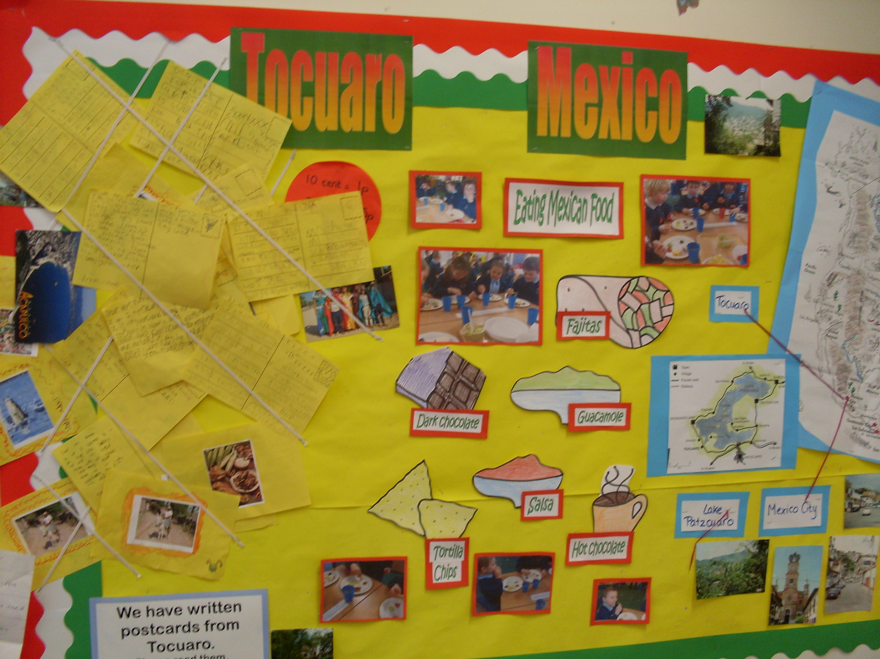
We have sent postcards to Mrs. Thomas to describe Tocauro.

We have tasted Mexican food and described it. Our menu was :
Salsa and Guacamole dips with Tortilla Chips
Chicken Fajitas
Dark chocolate
A drink of hot chocolate.

We have learnt a Spanish song.

