On the first day of Christmas my true love sent to me ………..
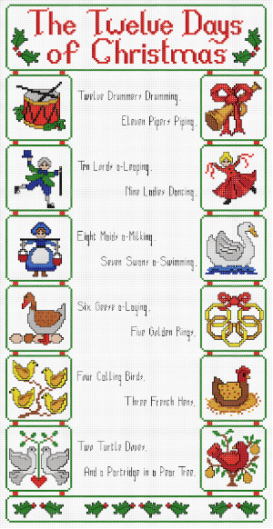
…………………………………………………………….
On the twelfth day of Christmas my true love sent to me
Twelve drummers drumming
Eleven pipers piping
Ten lords a-leaping
Nine ladies dancing
Eight maids a-milking
Seven swans a-swimming
Six geese a-laying
Five gold rings
Four calling birds
Three French hens
Two turtle doves
And a partridge in a pear tree
Christmas Problem Solving

How many nests would is needed for all of the birds?
Could each species of bird have a partner?
How many pairs of shoes in the song?
How many musical instruments in the songs band?
If each of the men found a bride in the song, how many weddings would there be?
How many drumsticks? (Could be a trick Q)
If each milk-maid’s bucket carried 6.5 litres of milk, how much milk was collected?
Each piper was on a rota, they had to play for 2 ¼ hours per shift. If the pipers played continuously throughout the 12 days, how long did each piper play?

Discuss your thoughts first with an adult or big brother /sister.
There could be more than one correct answer!
Show workings out either as jottings or images/diagrams.
Now create two more problems to solve.
Answers in your homework books please.

