
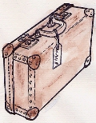
Week 4 Homework WW2 Topic based linked with English. All groups.
To be handed in on 4.10.10
Use what you have learnt about evacuees this week to help you.

Imagine it is September 1939. You live in the country. One or more children have recently been billeted at your home. Write a page from your diary. What do you think of the child or children? You could write about ‘their behaviour’ ‘their clothes and appearance’ ‘their manners and language’ their eating habits’ whether they are settling in well.

September 1939
Dear diary,

