Rectangles Numeracy Homework Autumn Term Week 7
To be handed in 1.11.10
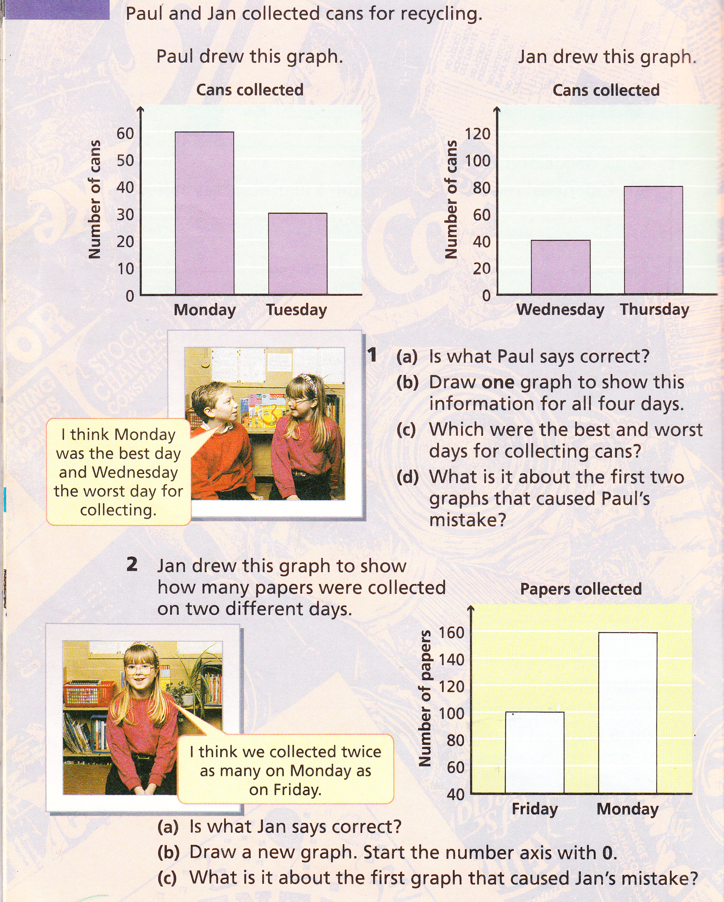
Data Handling - Recycling

