Triangles Numeracy Homework Autumn Week 7
To be handed in on 1.11.10
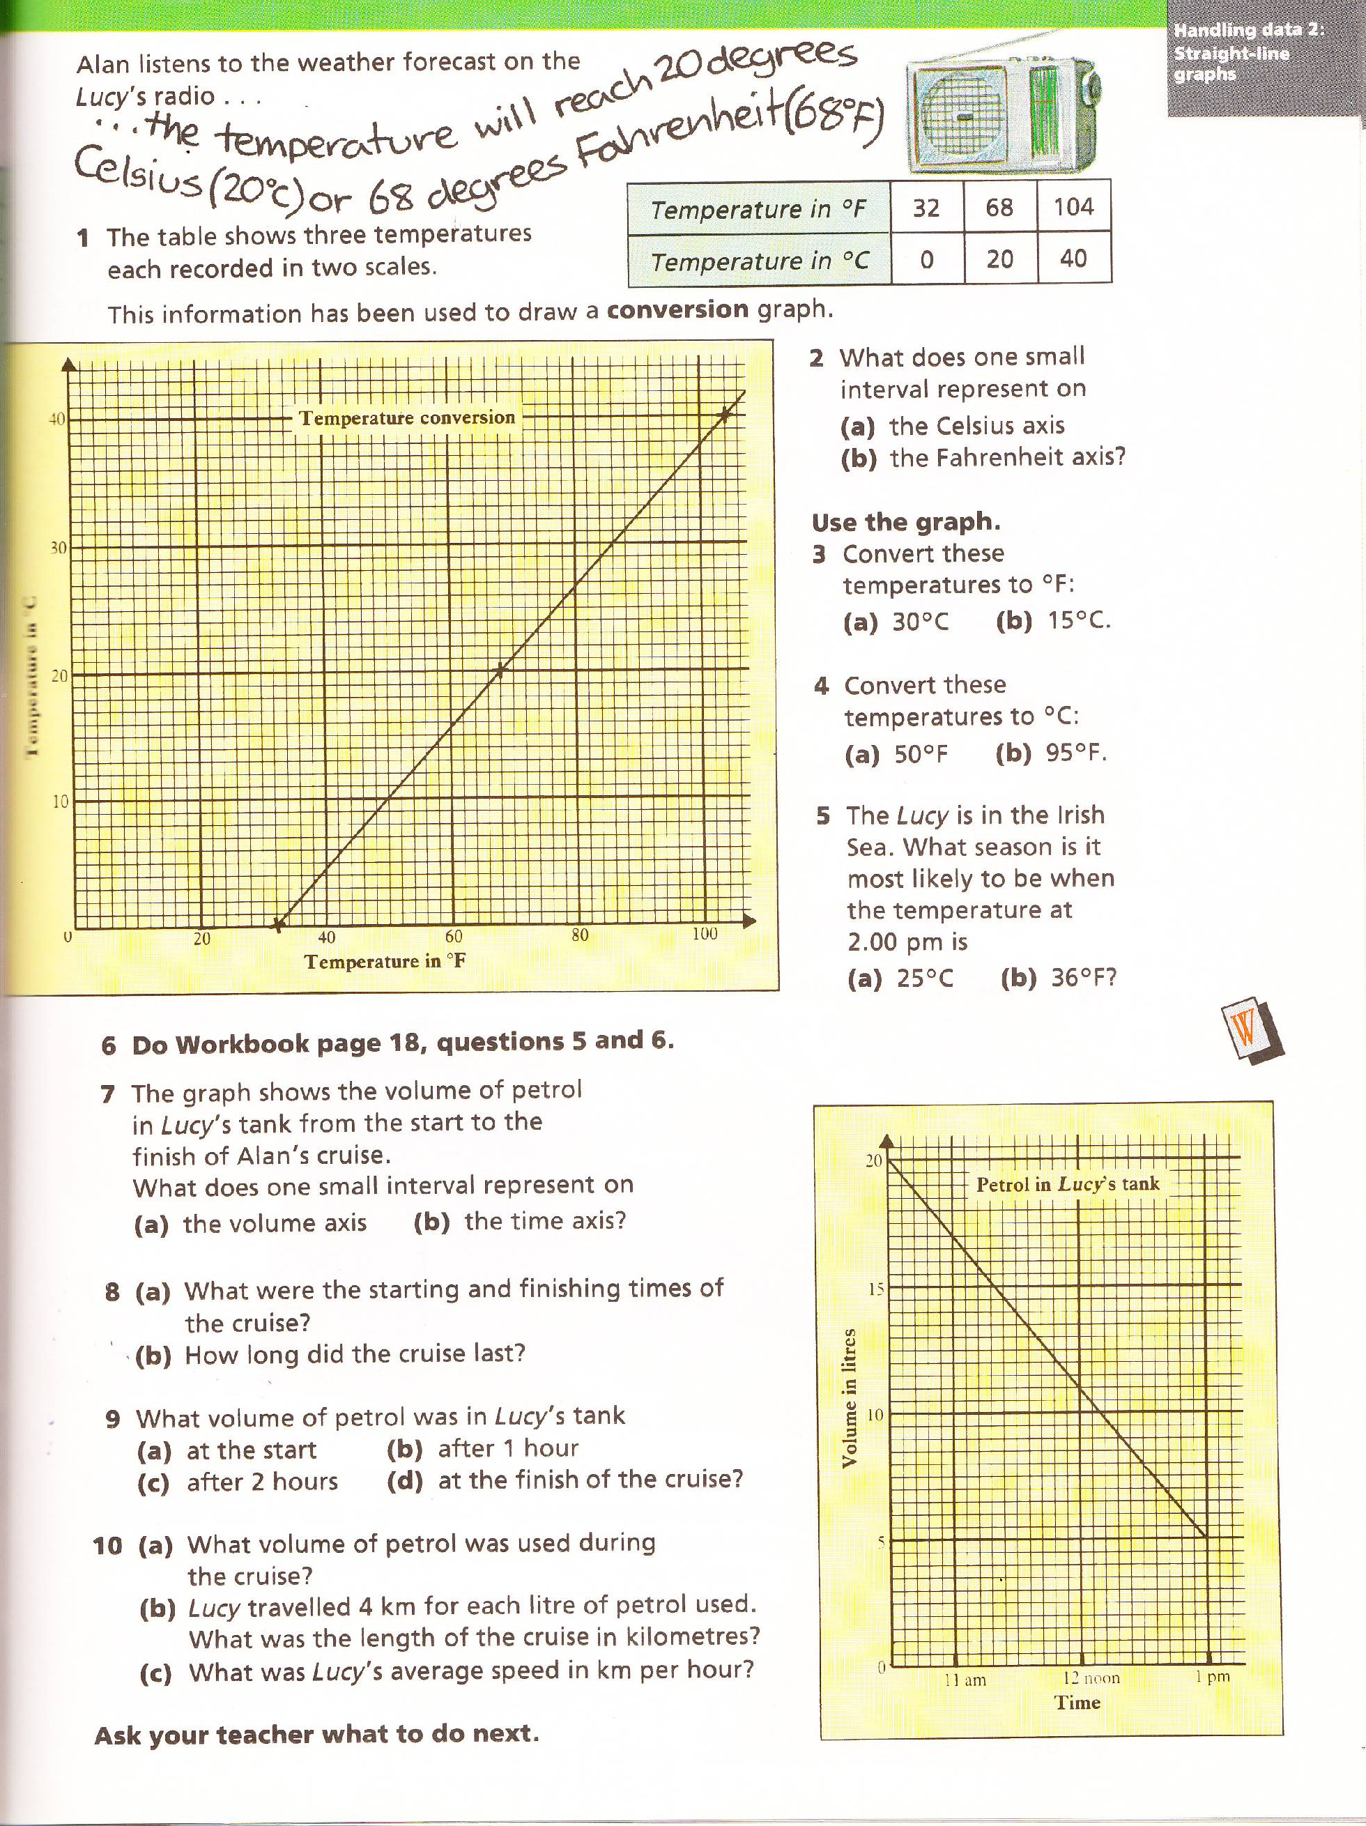
Omit question 6 please.

