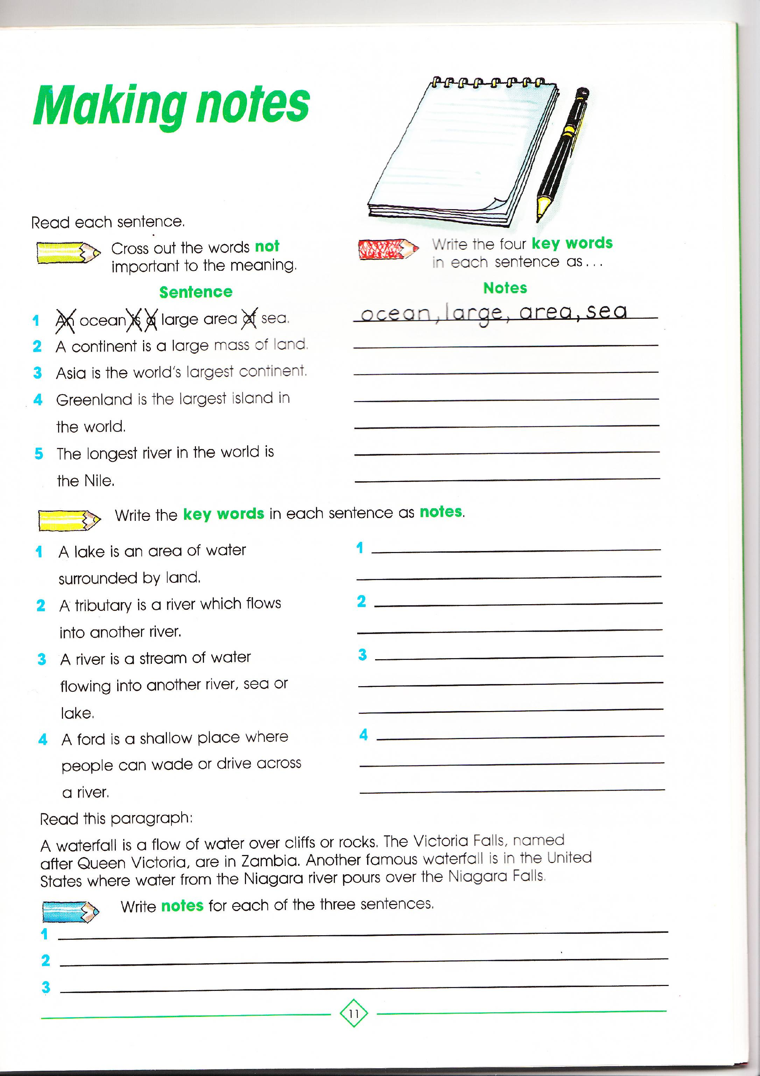
Panthers Literacy Homework Autumn WEEK 9
To be handed in on 15.11.10

