Tigers Literacy Homework Autumn WEEK 9
To be handed in on 15.11.10
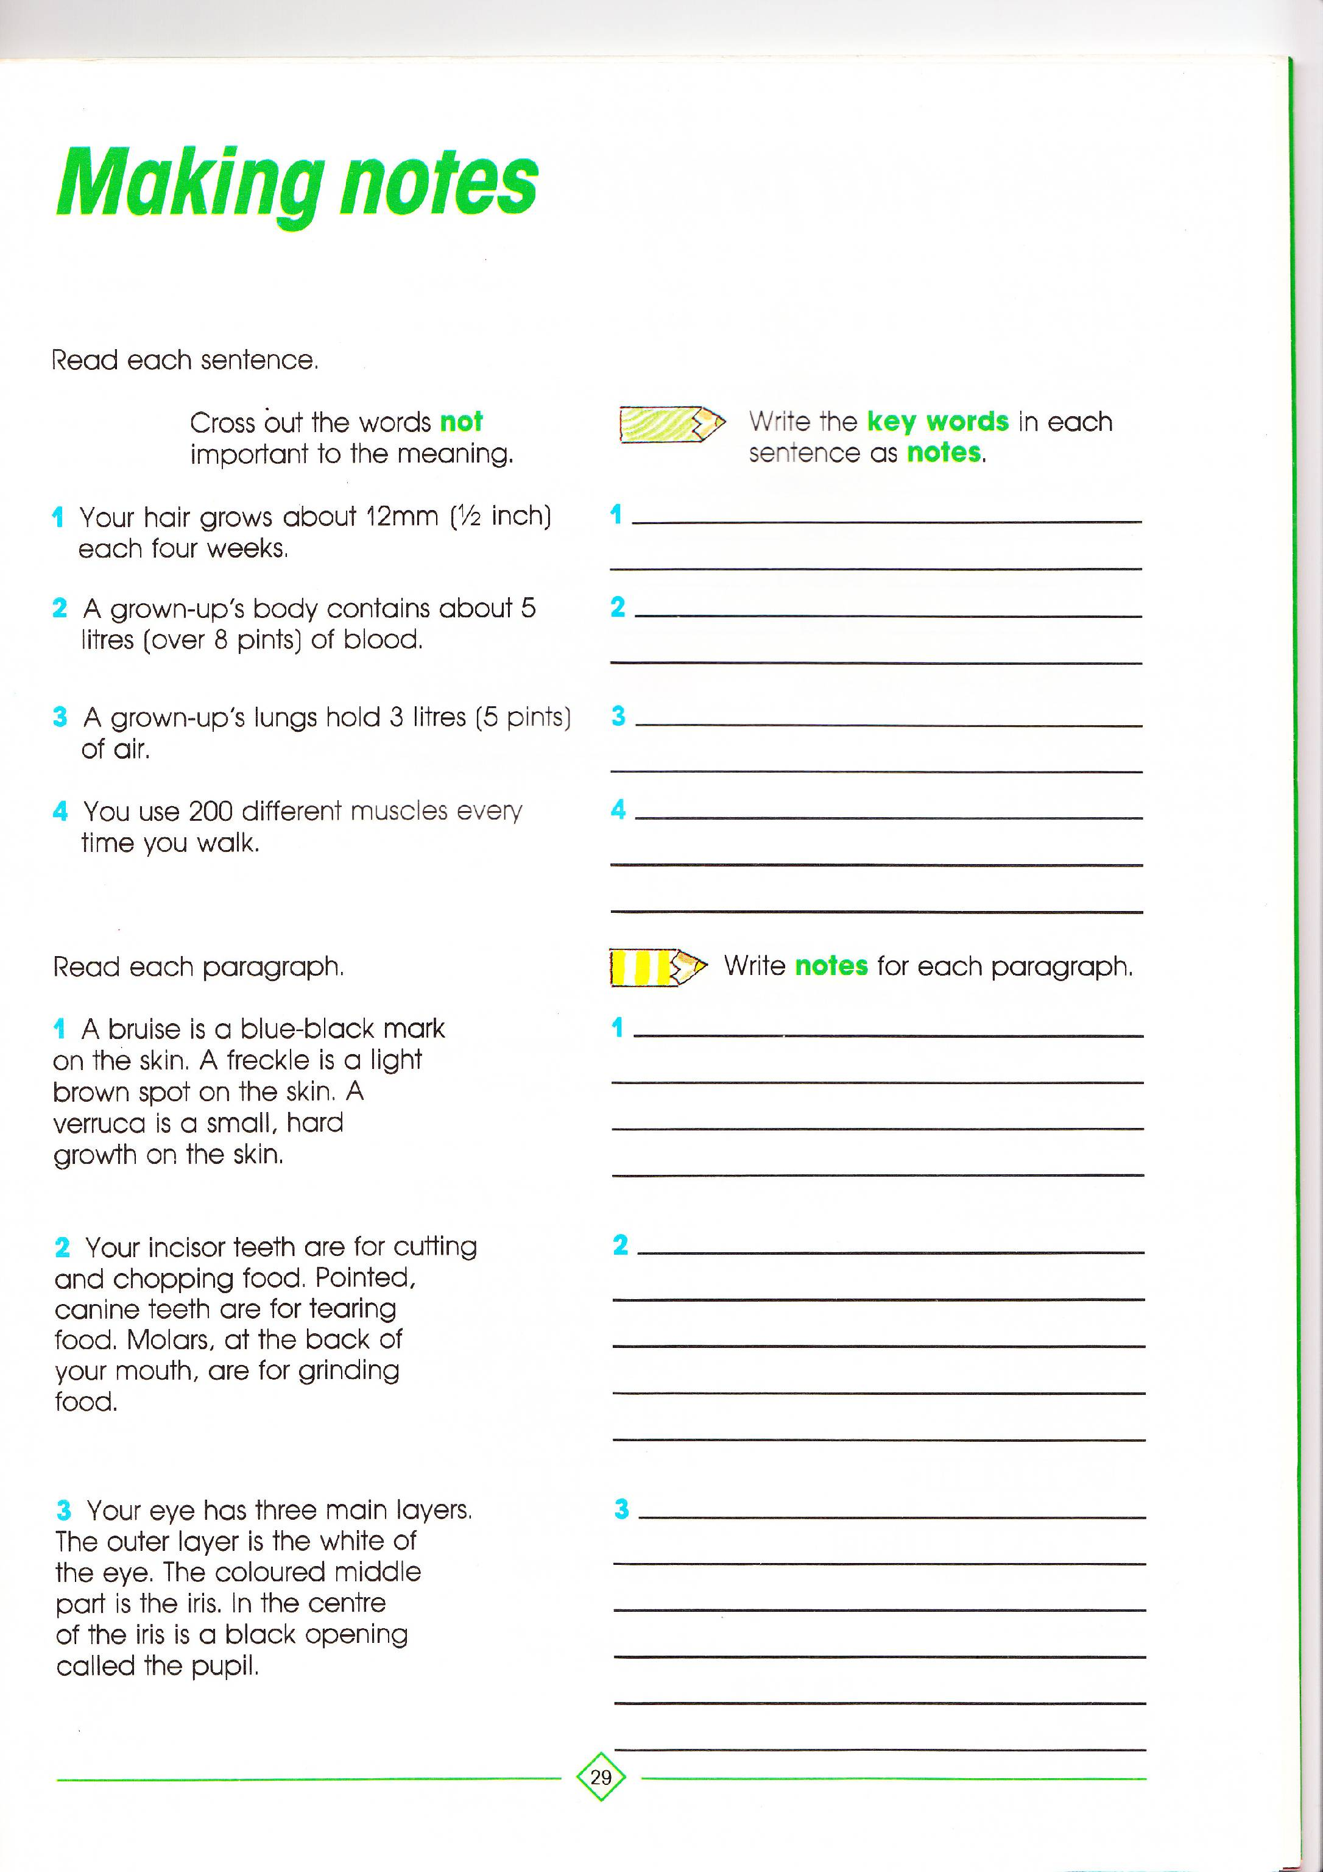
When complete write out a paragraph from your reading book and highlight the key words.

