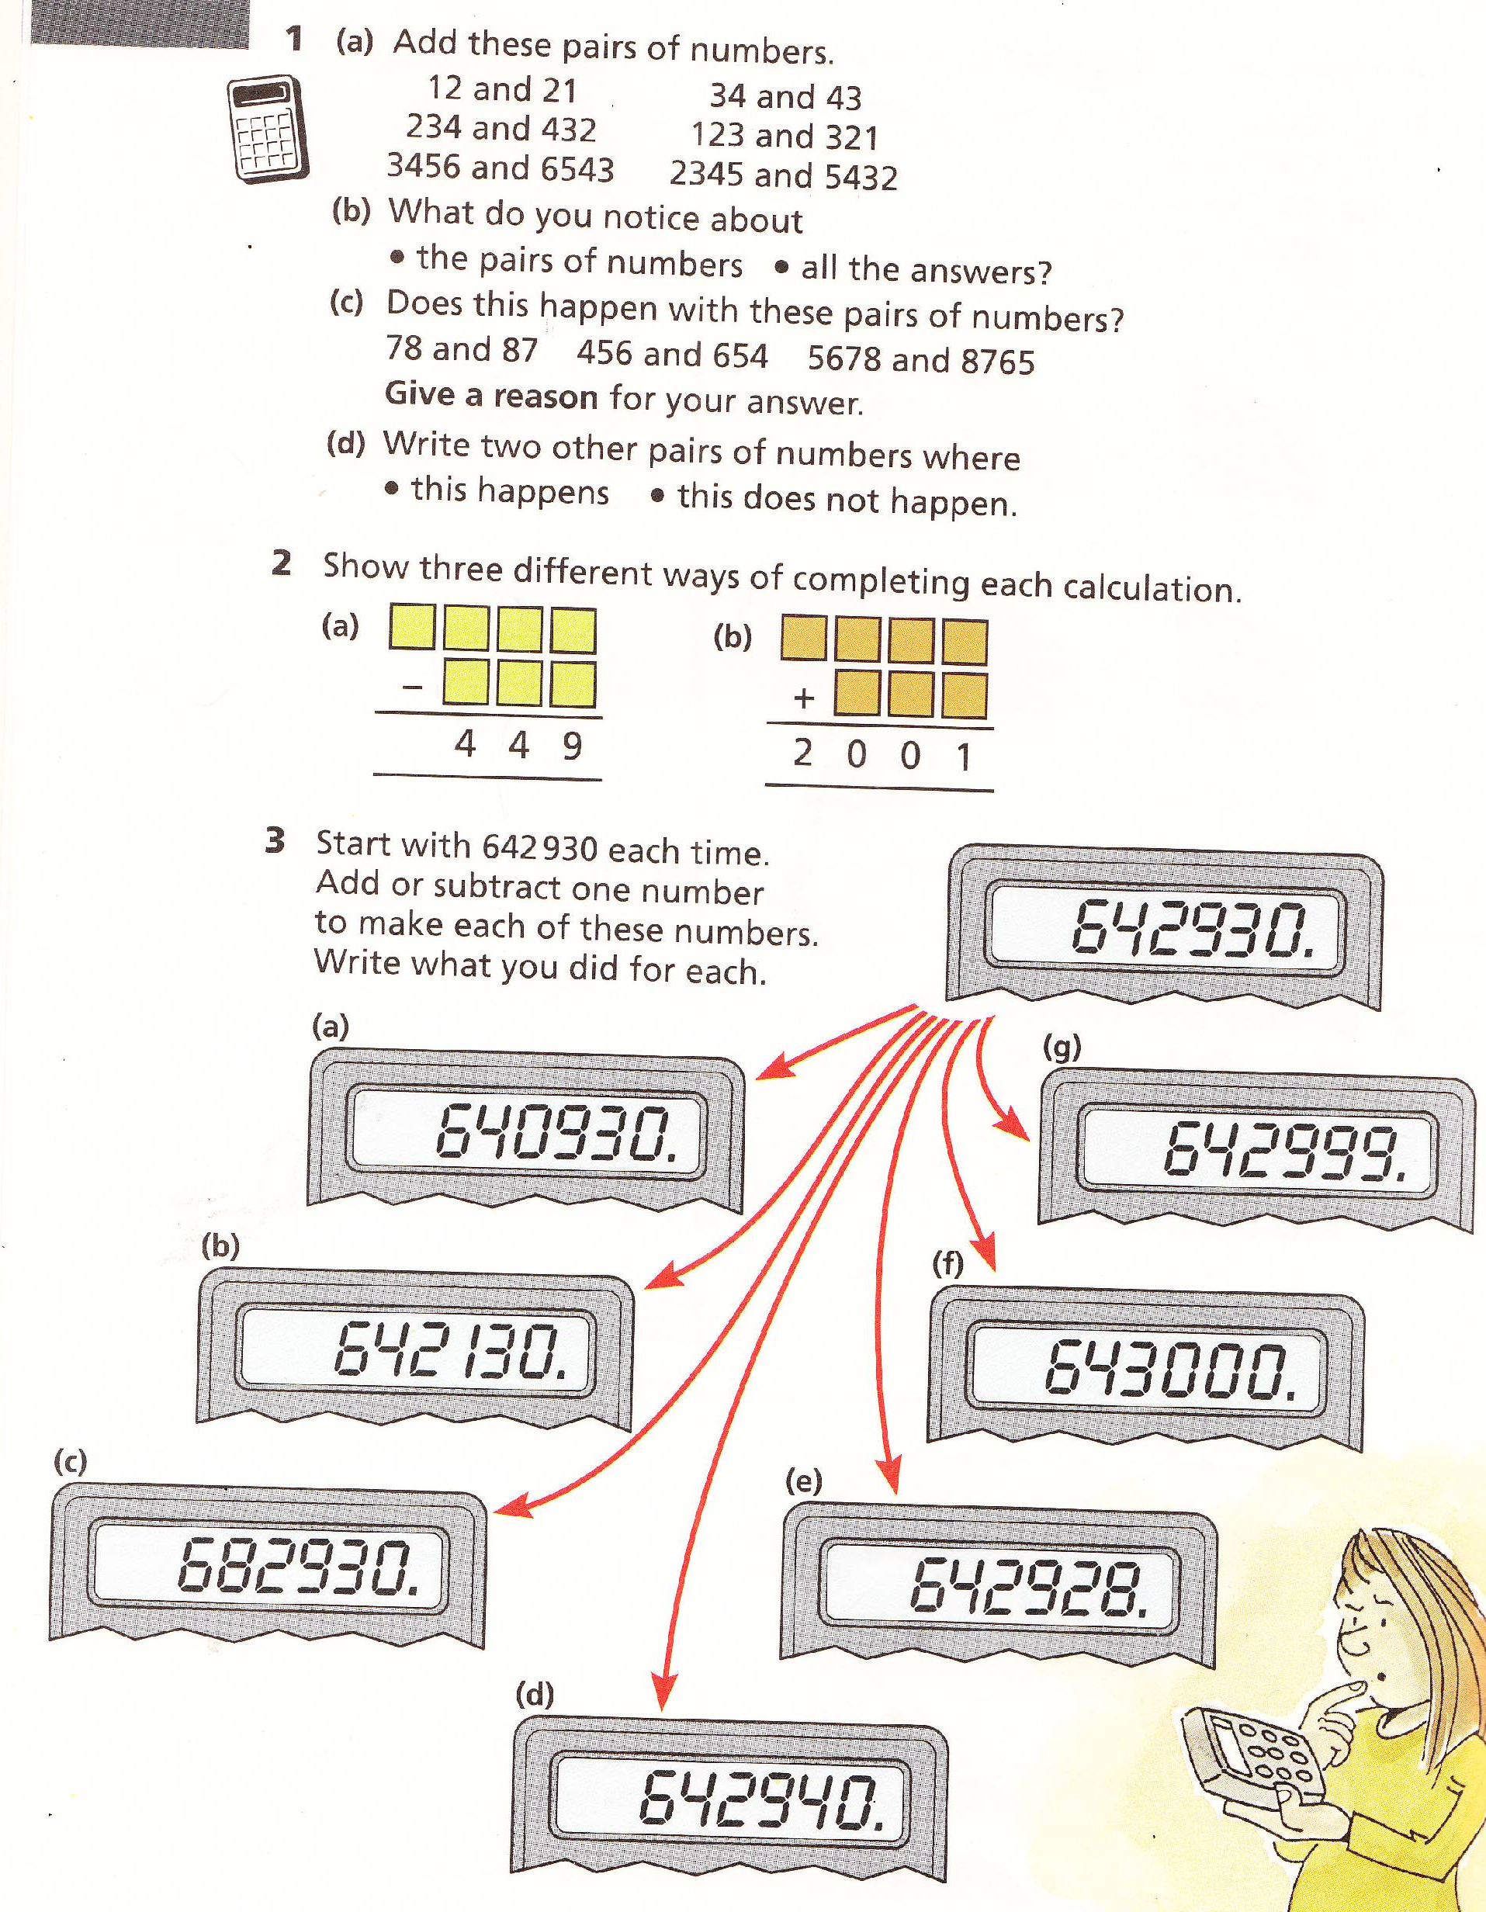
Squares Numeracy Homework Spring 2011 Week 2 To be handed in on 17.01.11

You can use a calculator for this.

