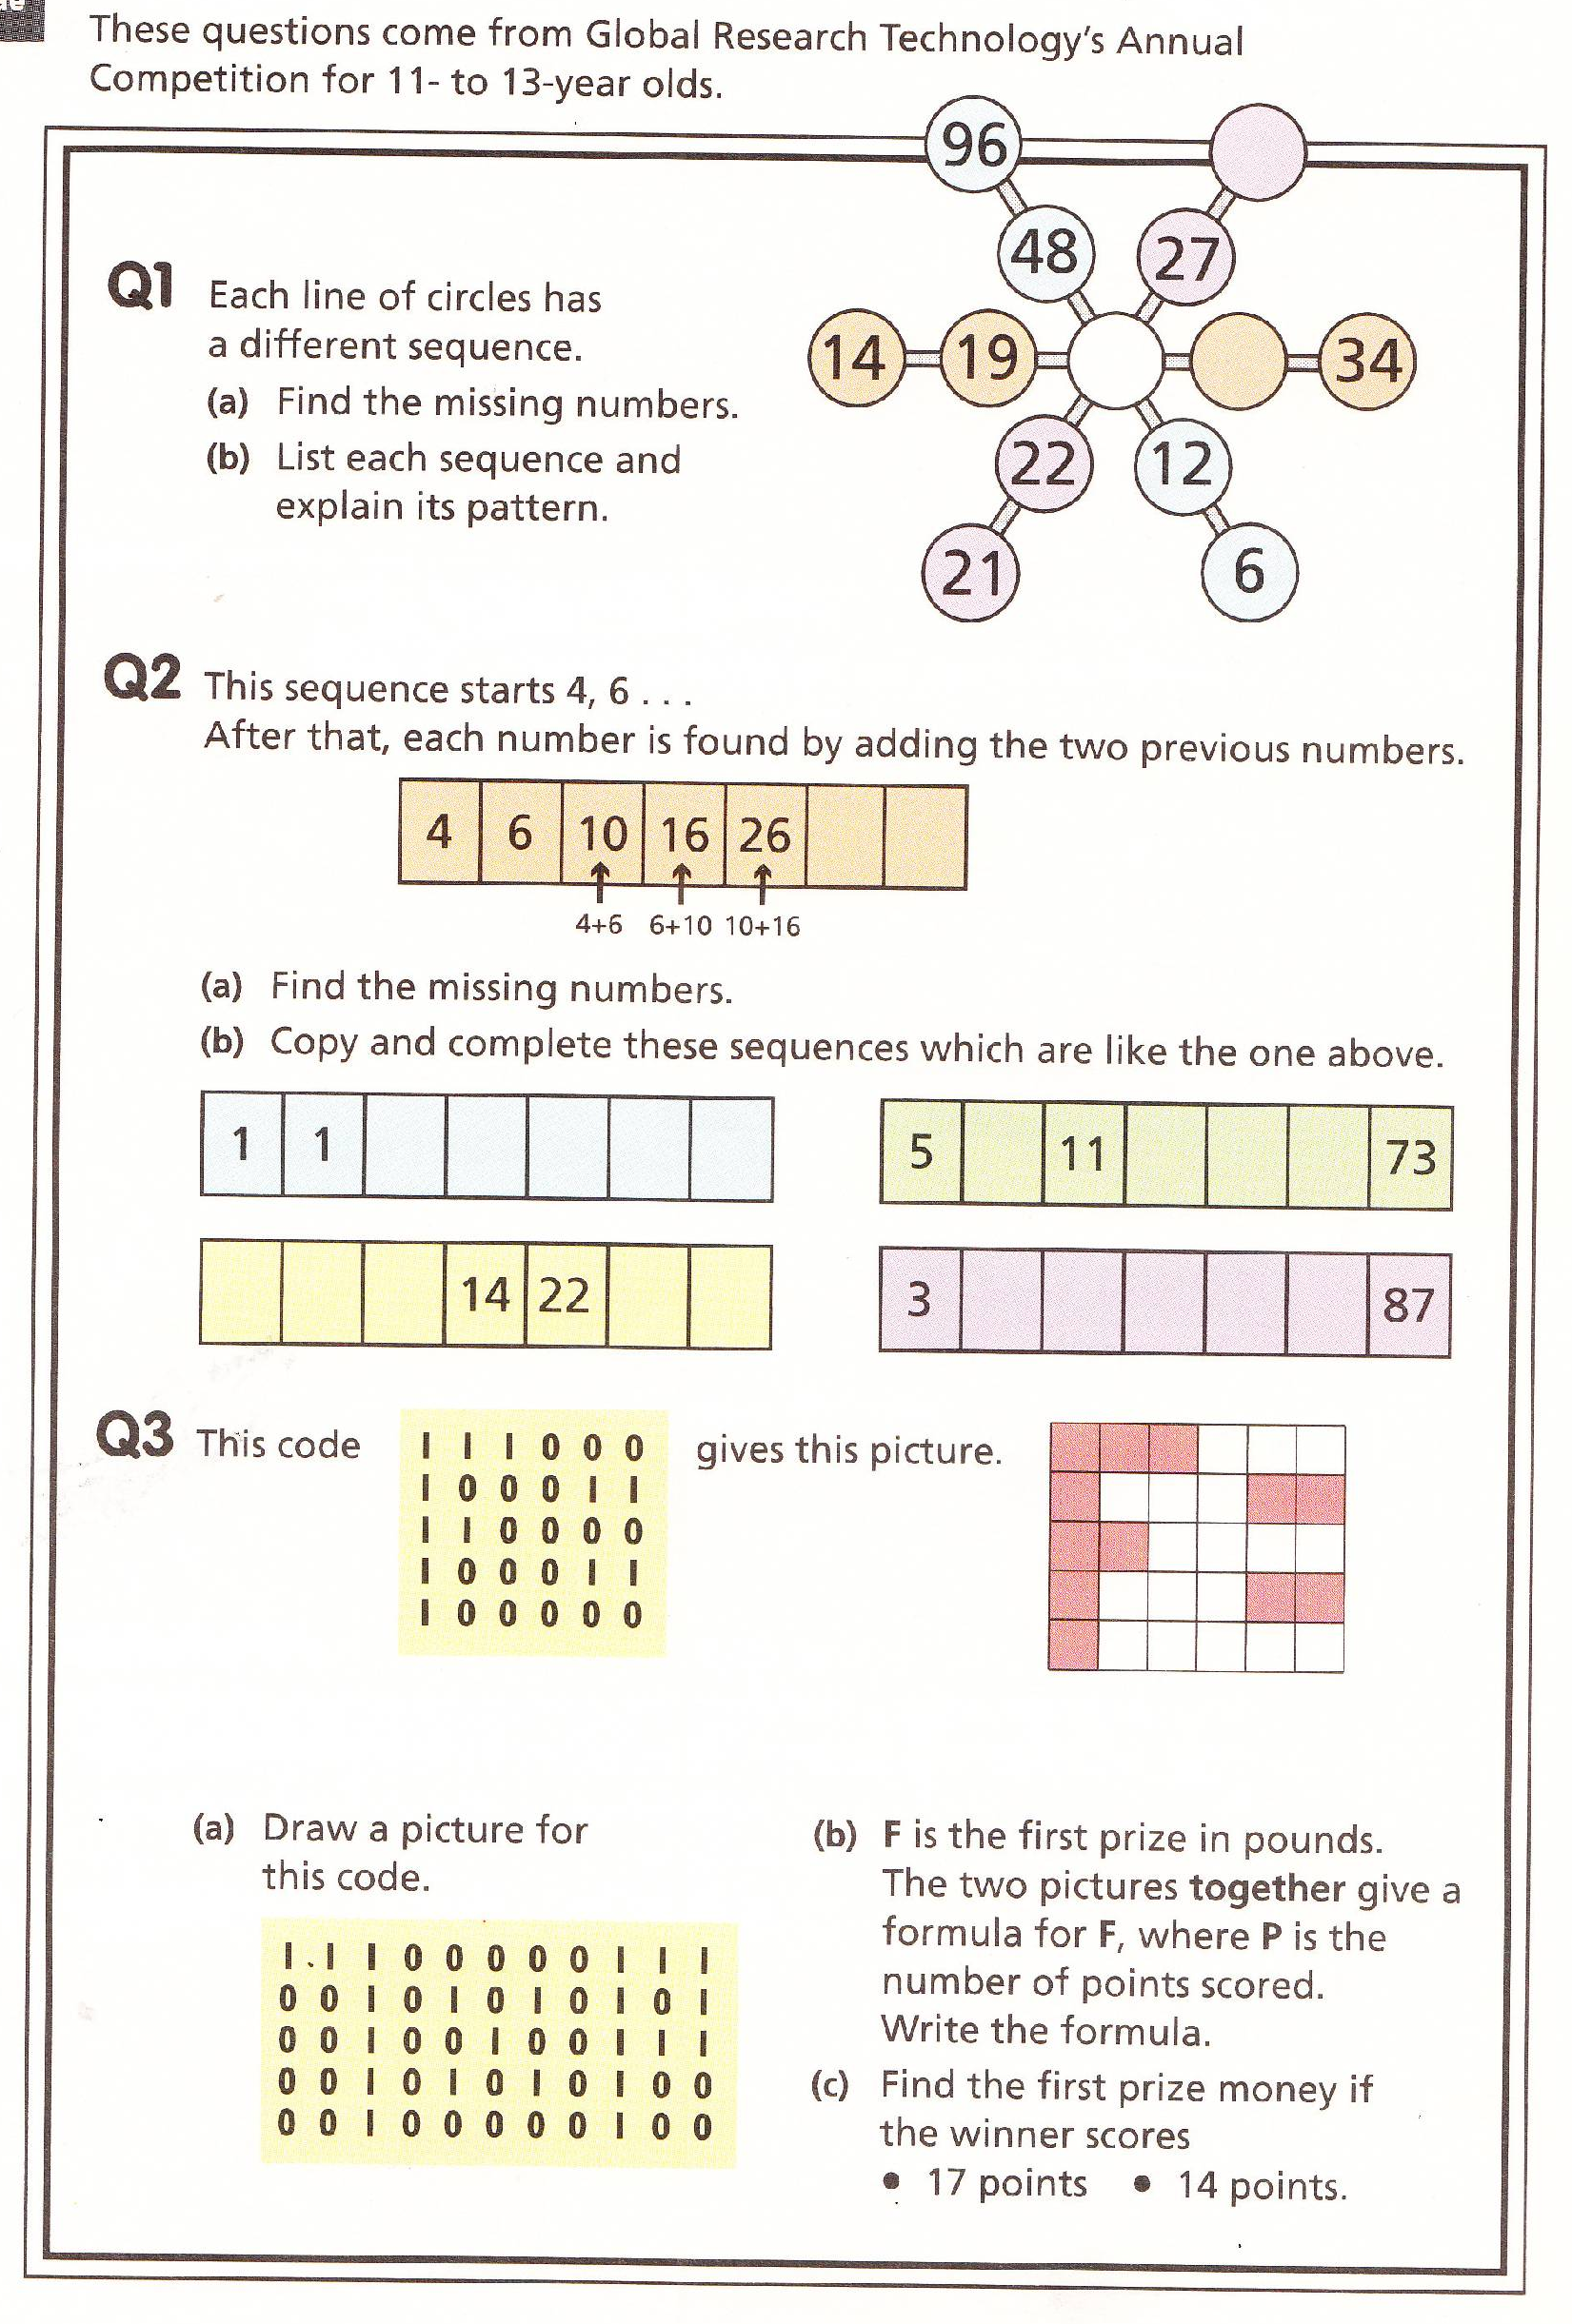
Triangles Numeracy Homework Spring Week 2 2011 To be handed in on 17.01.11

