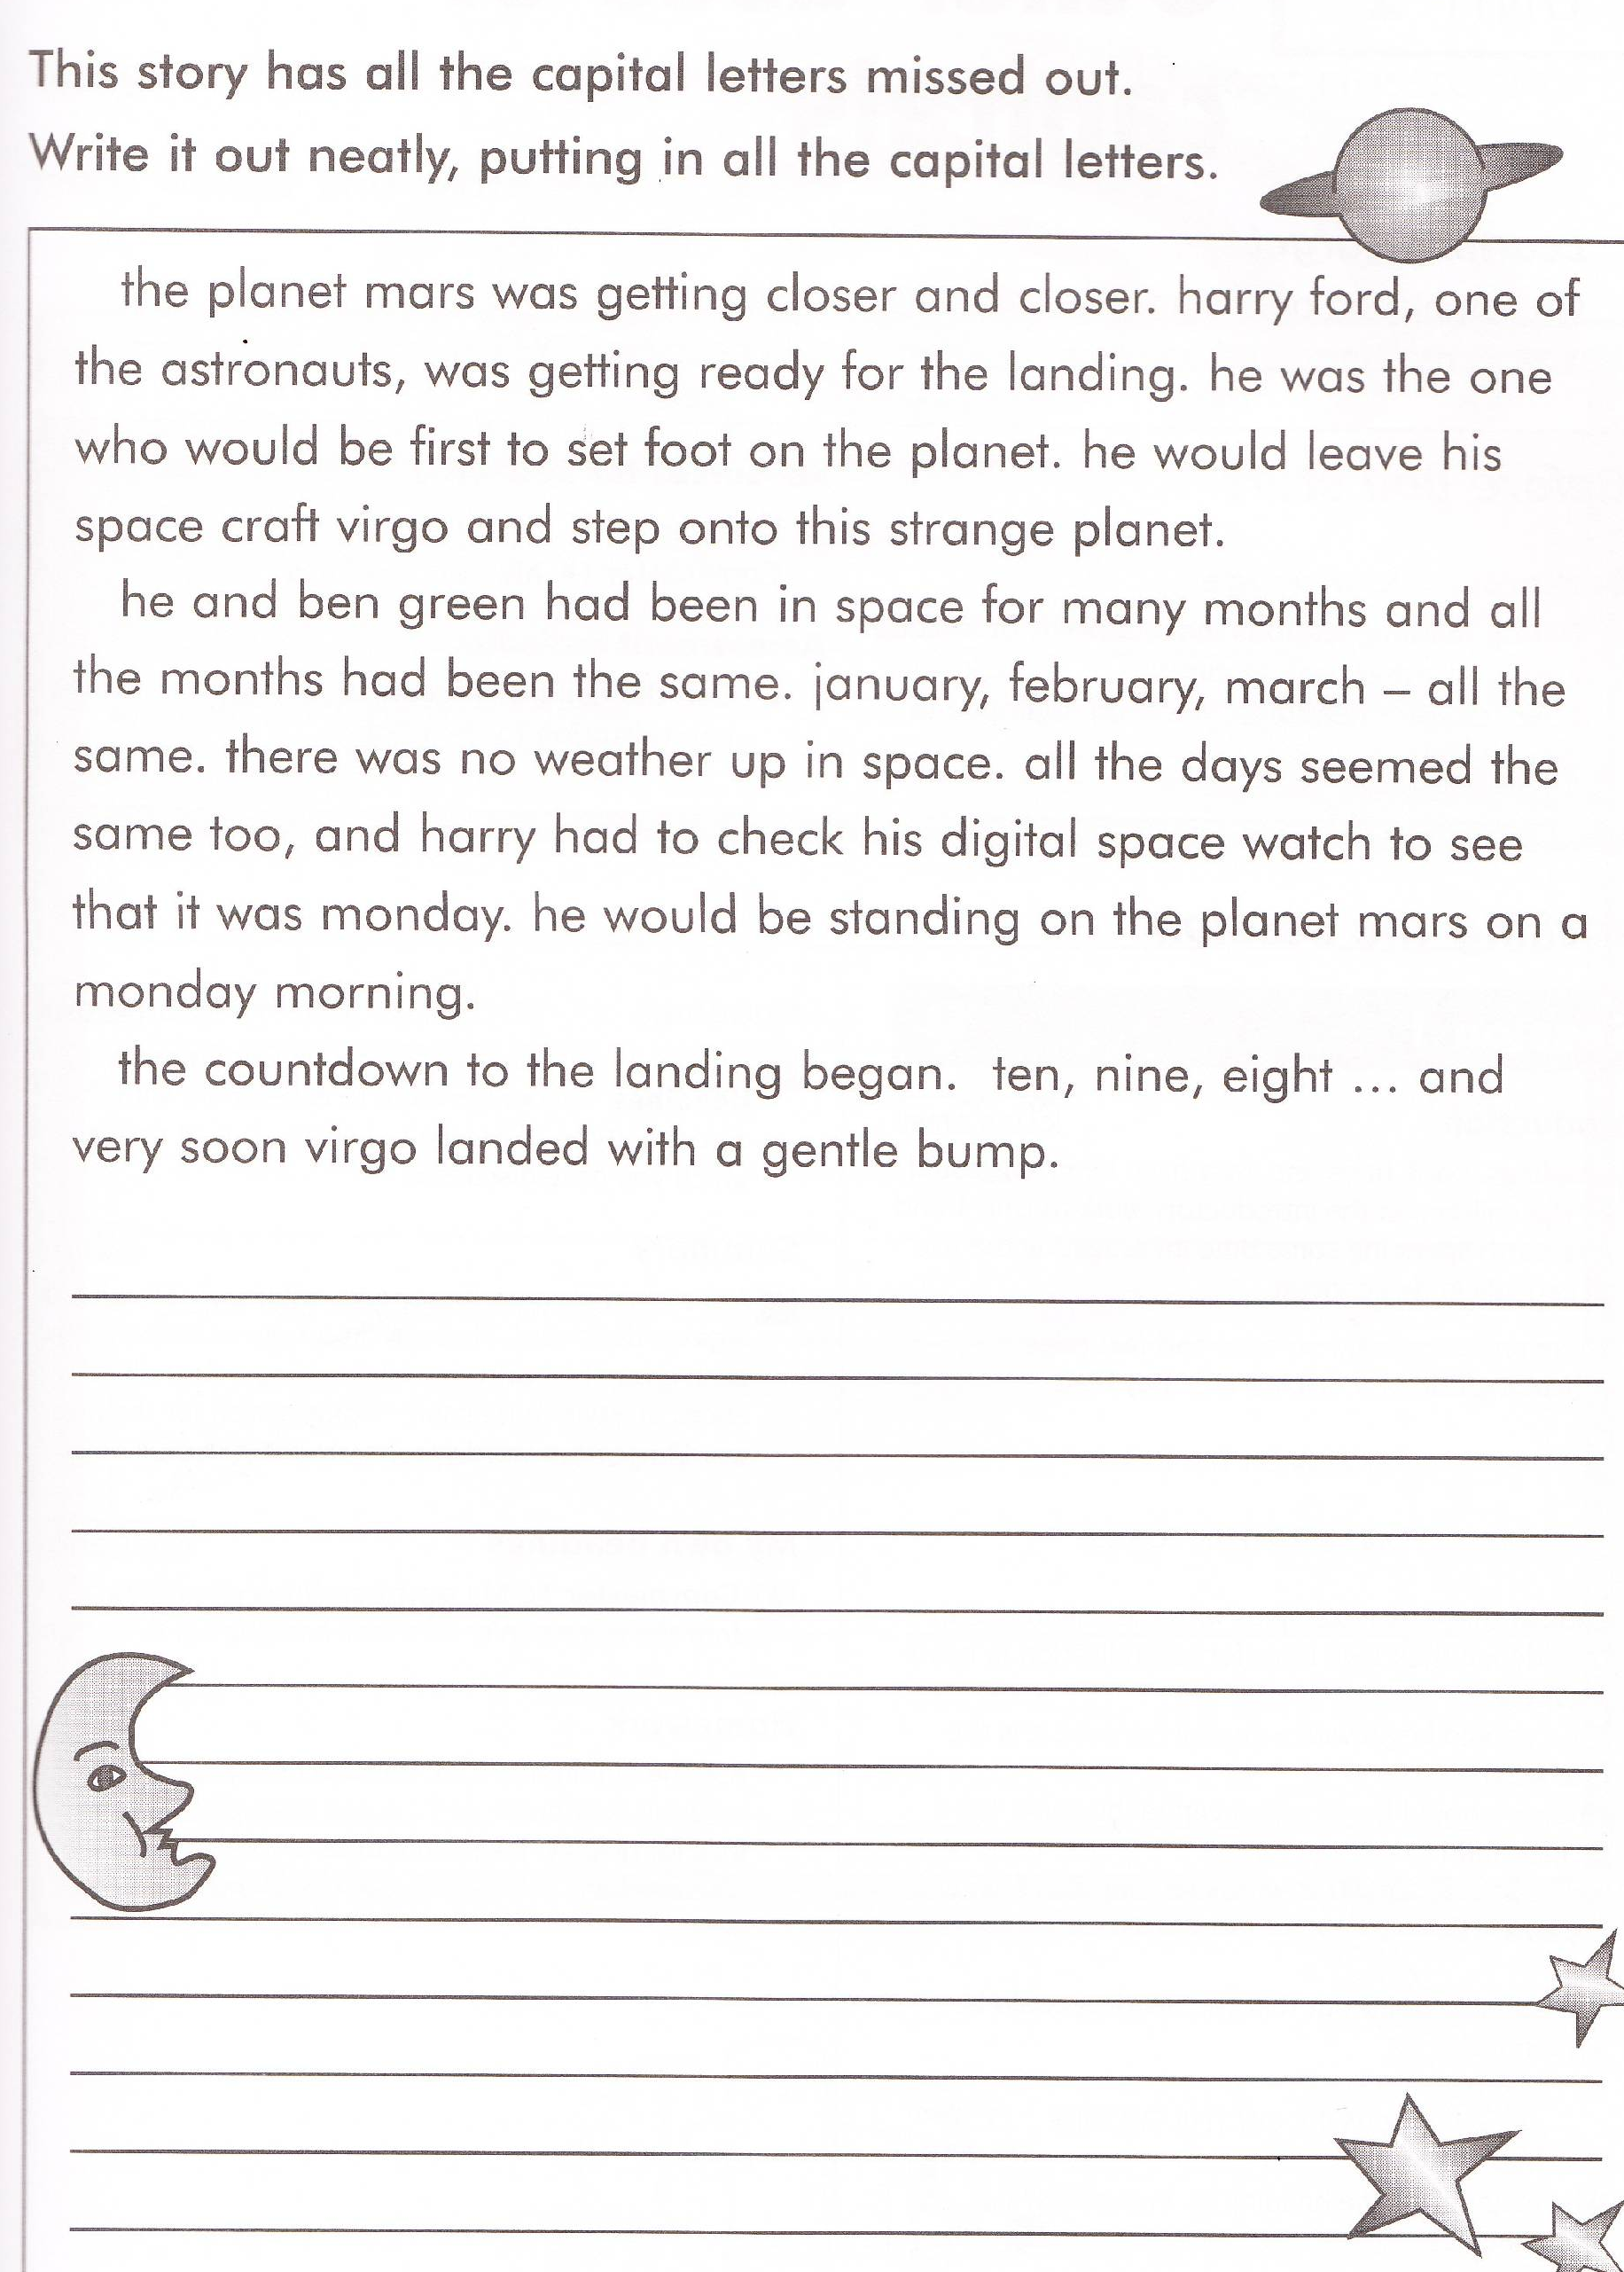
Literacy Homework Spring Week 1 Lions and Cheetahs.
To be handed in on 10.01.11

