Tigers and Panthers Homework Spring Term Week 1
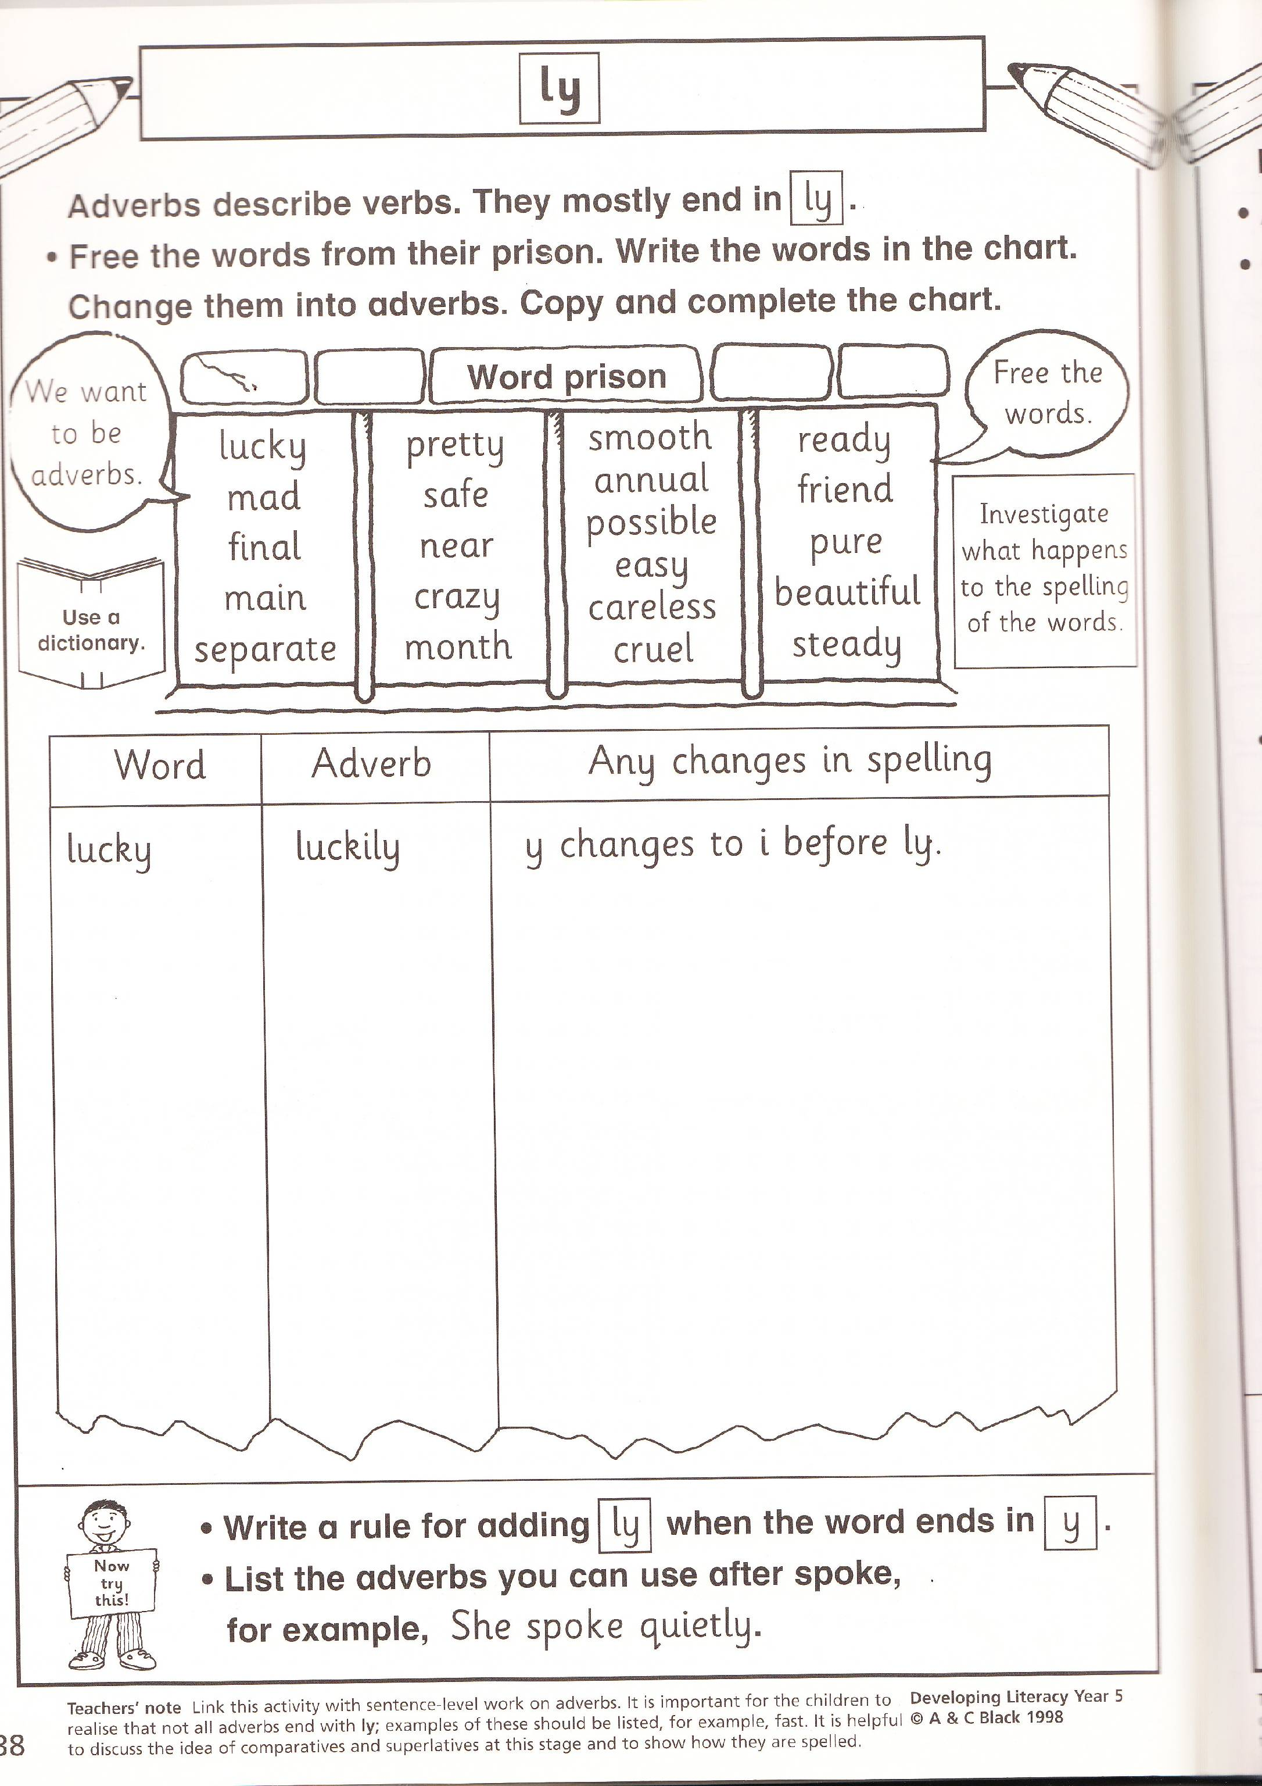
To be handed in on 10.1.11

