Lions and Cheetahs Homework Spring Week 3 To be handed in 24.01.11

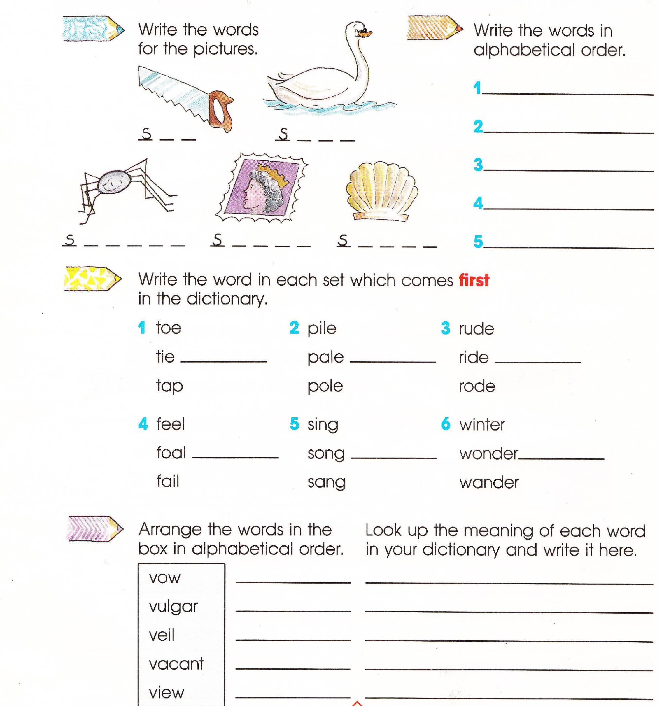
USING DICTIONARIES –REMEMBER WORDS ARE ARRANGED IN ALPHABETICAL ORDER

