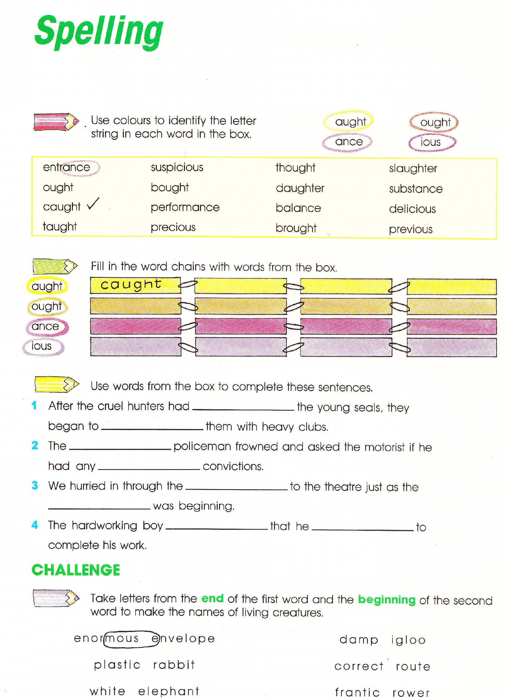
Panthers Literacy Homework Spring Week 3 To be handed in on 24.01.11

