Squares Numeracy Homework Spring 2011 Week 4
To be handed in on 31.01.11

Reading Scales Spring Balance

Name Date

The scale shows 1 Kilogram, each big division
is 100 grams, each small division is 20 grams
0

100

200

300

400

500

600

700

800

900

1000

Write in the reading for each of the arrows

1Kilo
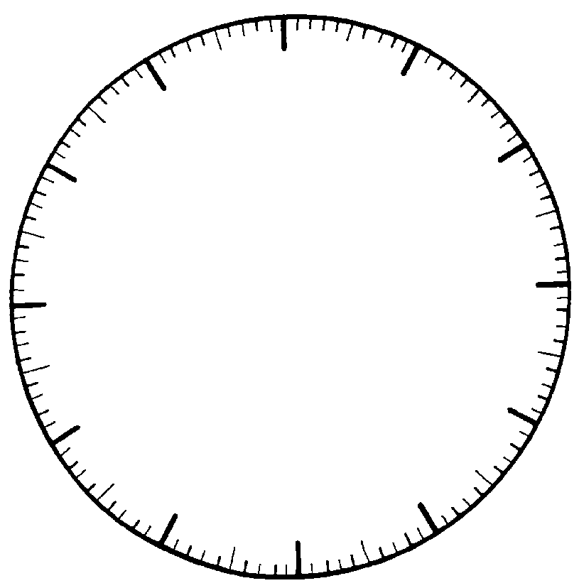
Reading scales
0
1100
1KG
900
800
200
100
300
400
700
600
500
grams

Name Date

Weighing scales can be read like a clock, the dial indicator moves as the weight increases. Each big line is 100g, each small line is 10g, the arrow shows 260 g

Draw arrows on the scale to show these weights

a) 520g, b) 400g c) 960g d) 1000g e) 180g

