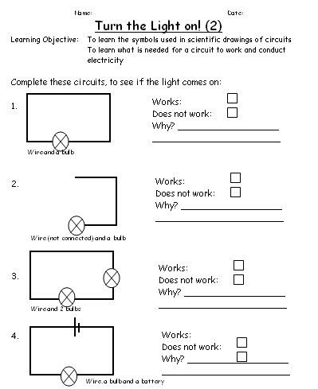
Rectangles Science Homework Spring 2011 Week 4
To be handed in on 31.01.11

