Fractions

Circles and Rectangles Homework Summer Week 3
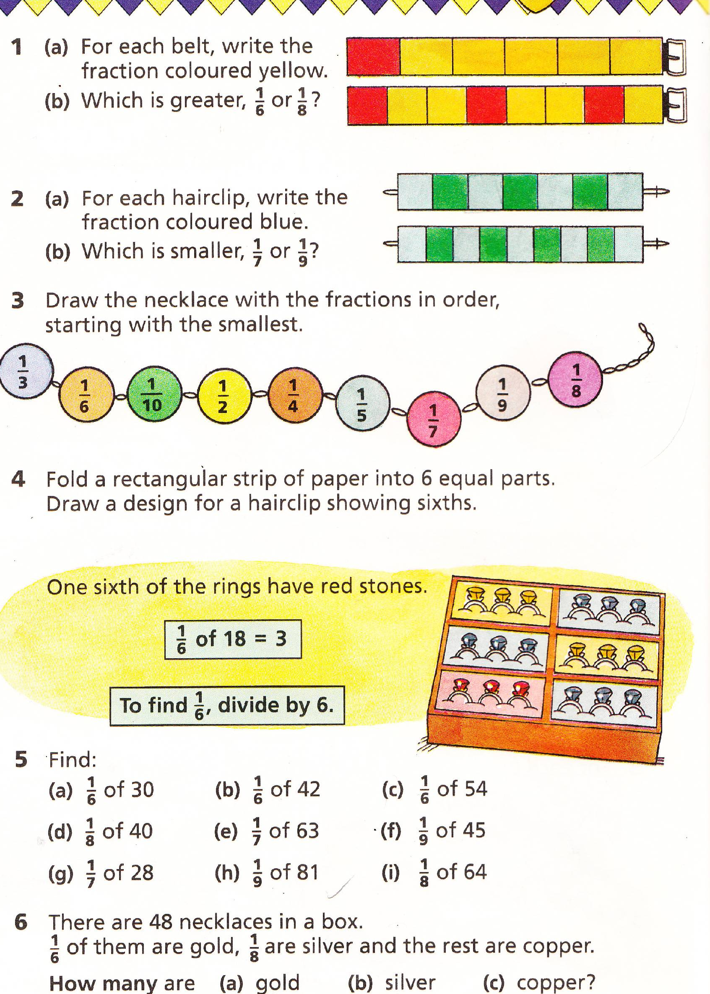
To be handed in on 10.5.10

