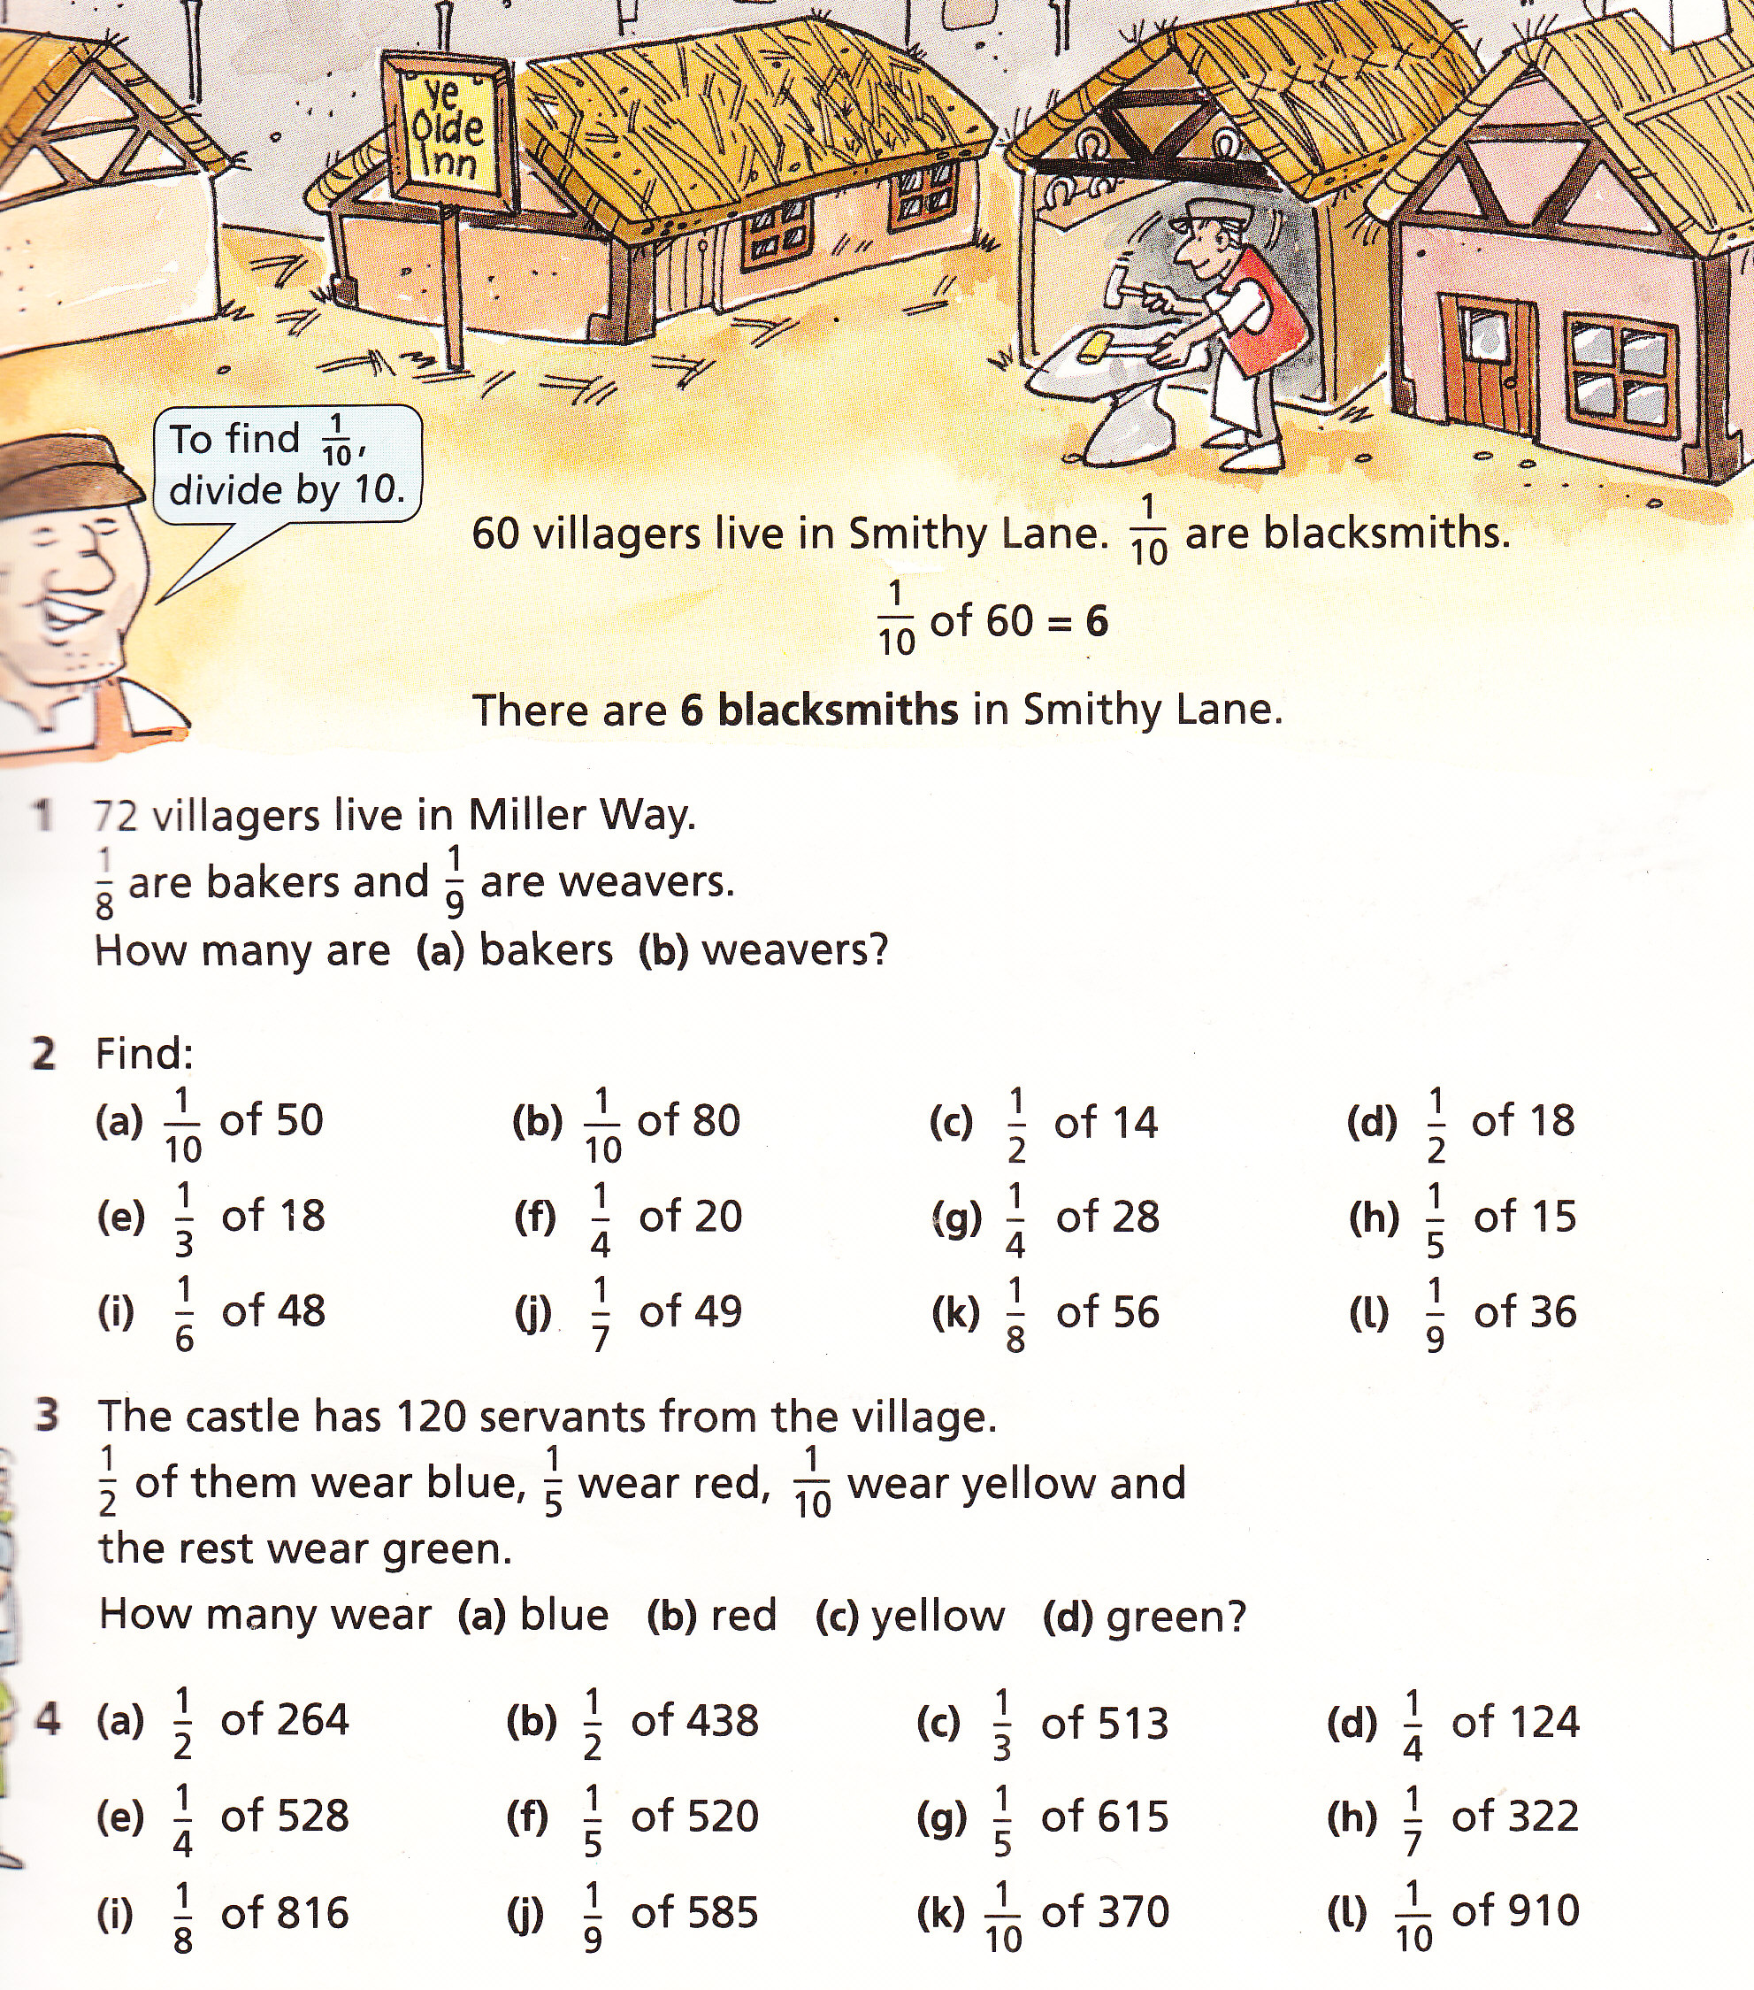
Squares Numeracy Homework Summer Week 3
To be handed in on 10.5.10

