Literacy Homework Summer Week 2 – All Groups
To be handed in on 9.5.2011
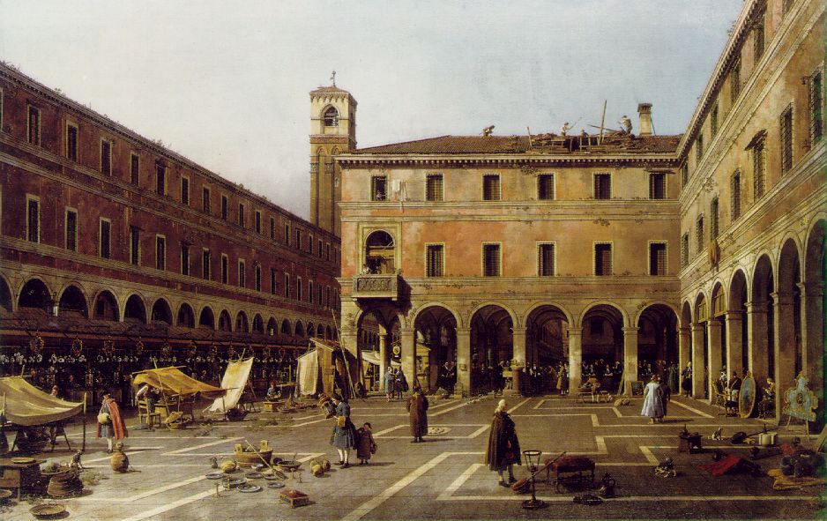

In our topic ‘The Holiday Show’ we will be finding out about famous artists. This picture is by the famous artist Antonio Canaletto and is a picture of a market square in Italy.

I would like you to do the following:
Describe in detail what you can see, hear and smell. Use your imagination as well as the picture to ensure that your description is vivid, lively and realistic. When you read your writing to someone else they should be able to imagine the scene you are describing.

Use VCOP to help you. Don’t forget metaphors, similes and alliteration.

Allow 5 minutes brief planning time and 15 minutes writing time. You should aim for at least half to three quarters of a page of A4.

