Class 4 Literacy Homework Summer Week 3

To be handed in on 16.5. 2011

A Family Of Characters
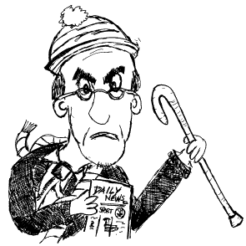 | 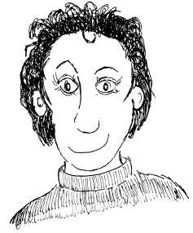
Grandfather | Mum
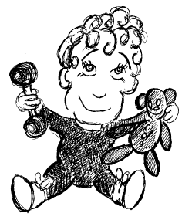 | 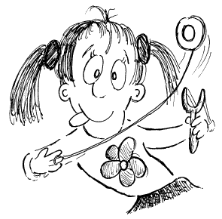
Baby Brother | Little Sister
Write about a member of this family.
Describe what they look like.
Describe what kind of person they are.
Describe how they get on with the other characters.

