Rectangles Numeracy Homework Summer Week 4
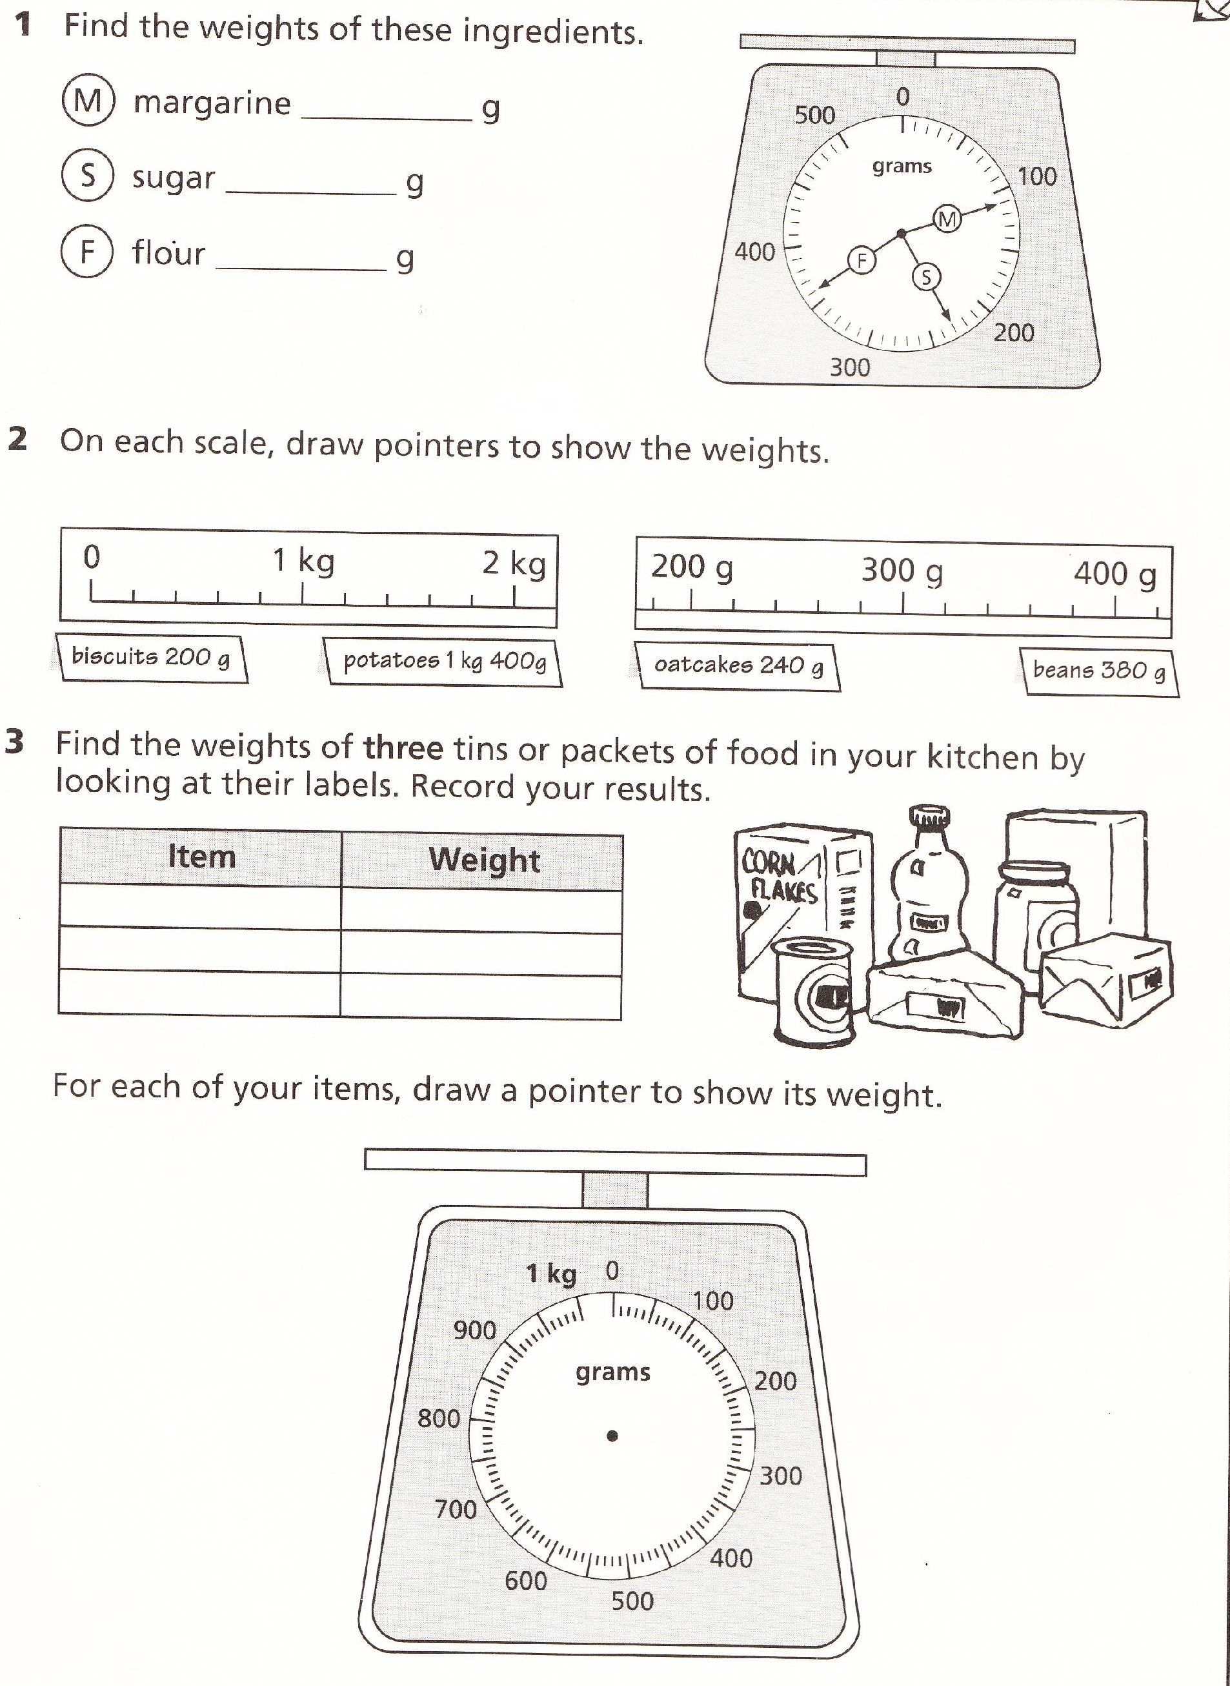
To be handed in on 23.5.2011

