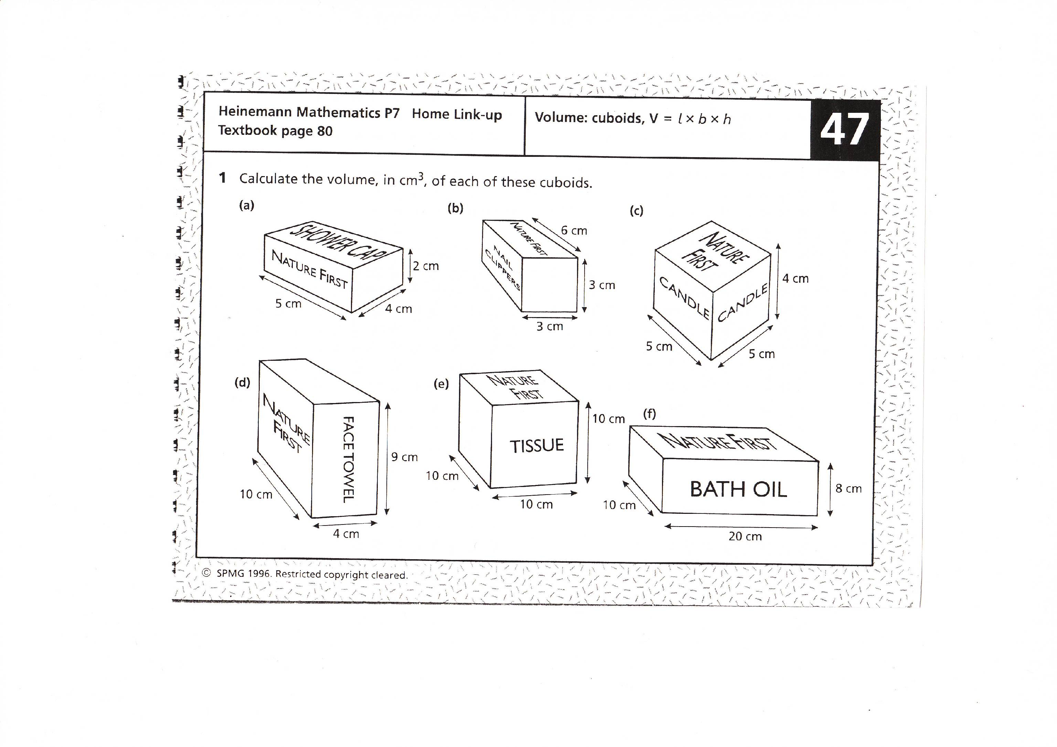
Triangles Numeracy Homework Summer Week 4 To be handed in on 23.5.2011

Volume: cuboids, V= l x b x h

