
FRIDAY FORTNIGHTLY
15th January 2010
www.mickleton.gloucs.sch.uk

CALENDAR
Friday 12th February
Class 3 assembly at 2:30 p.m. Friends of School Valentine Disco – 6:30 – 8:00 p.m. Red and black theme
‘Tyre park’ being installed
School breaks up at 3:15 p.m. – half term
Monday 22nd February
Return to school
PLEASE REMEMBER THAT YOU ARE ALWAYS WELCOME TO ATTEND OUR PRAISE ASSEMBLIES ON FRIDAYS AT 2:30 P.M.

SNOW, SNOW GO AWAY!
Thank you to everyone who has helped to get Mickleton School open and kept it running. We are particularly indebted to Mr John Coldicott and Mrs Walker. Mr Coldicott spent a freezing evening clearing the car park to make it accessible. Mrs Walker has spent many hours clearing and salting the grounds so that it is safe for the children to come to school. I am sure you would like to join us in saying thank you to both of them. The adverse conditions have seen a wonderful community spirit at school; thank you to the staff for continuing to get to school and to you for trudging through the snow to bring your children to school. Let’s hope it all goes very soon.
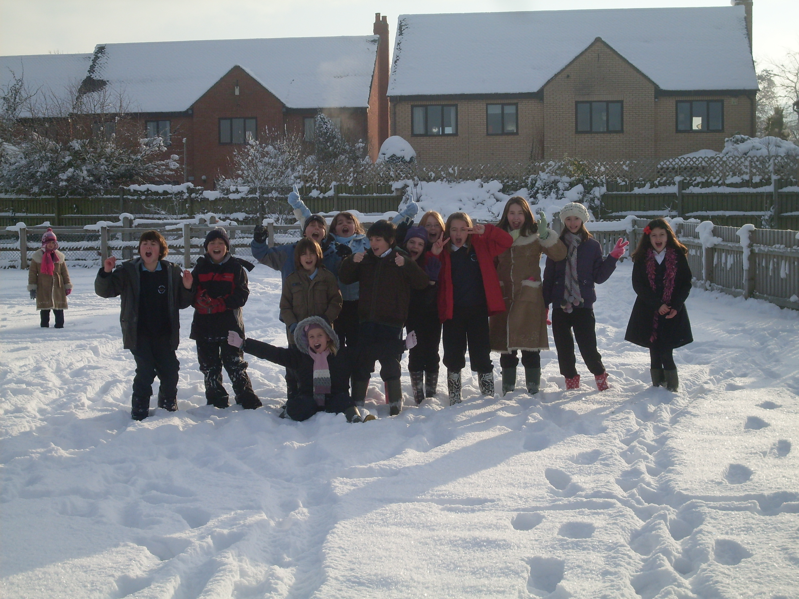
Have you seen the ‘Huff ‘n’ Puff’ snow caterpillar made by Mrs Walker, the team leaders and our children? He looks fantastic - well done.

We would like to say a warm welcome to Noah Hinton who joined Mickleton School this term.

INITIAL TEACHER TRAINING
We are delighted to welcome our third teacher training student to Mickleton. Ms Lois Self will be working in Class 2 from February 1st for a six week period. Ms Self is training at the University of Warwick. Please do introduce yourselves to her. I am certain that Class 2 will benefit from having another teacher working with them.

EXTENDING SCHOOL DAY MEETING
Thank you to the parents who attended the meeting on Thursday 14th January. We discussed the reasons for the proposed extension to the school day and looked at other possibilities. The feeling of the majority was that this will allow us to continue to provide high quality guided reading sessions for our children. We know that these sessions are already having positive benefits for the children. I will send you formal notification of the outcomes of our consultation by the end of January.

Broadmarston Lane, Mickleton, Chipping Campden, Gloucestershire. GL55 6SJ
www.mickleton.gloucs.sch.uk admin@mickleton.gloucs.sch.uk 01386 438393
The rescheduled Friends of School meeting will be on Wednesday 20th January at 7:30 p.m. Everyone is welcome to attend.
TEXT MESSAGING SERVICE
This has been very successful during the recent school closures and necessary alterations to school clubs. From this term we will also be using it to notify parents regarding praise assemblies. If your child is to receive a certificate at the 2:30 p.m. assembly on Fridays then we will send a text message on the Friday morning to let you know. If you have recently changed your mobile telephone number then please make Mrs Barnett aware. Thank you.

