NEWSLETTER 2 – OCTOBER 2010

Dear Parents,
I can’t believe that we have reached the end of our first half term already. What an exciting time we have had! We hope that you and your children have a good rest over the half term holiday and return, refreshed, ready for the run-up to Christmas.

SCHOOL TRIPS –this term has seen three classes go on fantastic trips. Class 2 visited Avoncroft Museum to look at houses, Class 3 became Tudors for the day at Mary Arden’s House and Class 4 went back to World War II with a visit to The Imperial War Museum. Thank you to all of the staff for organising such exciting visits for our children and thank you to you for supporting them so enthusiastically. Our youngest children are now preparing for their trip to West Midlands Safari Park for a ‘Santa Safari’. I think that this trip sounds very exciting; I wonder if they would notice someone a little larger tagging along?
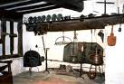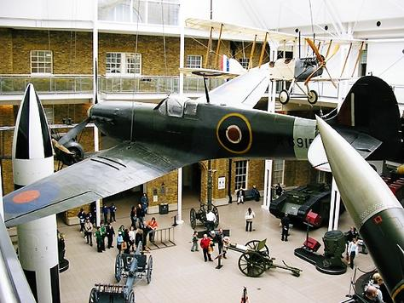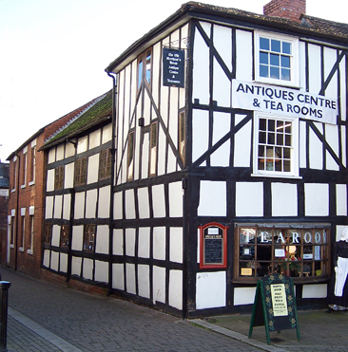
Mary Arden’s House Imperial War Museum Avoncroft Museum

HELPING IN SCHOOL – We are delighted with the number of parents who are helping in school each week. Your help with reading and supporting groups is absolutely invaluable. Thank you. We are, however, aware, that it would be fabulous for our children to read with gentlemen as well as ladies! So, we are calling all Dads, Grandads, big brothers, Uncles etc. If you could spare an hour a week to read with children we would be delighted to see you. Please contact me for a chat if you would like to find out more.

STAY & PLAY IN NURSERY – Mrs Richardson is also on the hunt for people willing to spend some time playing with children in our Nursery. You do not have to have a child in Nursery or Class 1, anyone interested would be welcome. Mrs Richardson is very kind and often provides yummy incentives so I am sure that biscuits and tea would come with the play. Please see Mrs Richardson if you could offer some time. Thank you.


FRIENDS OF MICKLETON SCHOOL – We would like to say a big thank you to our FOS for all their hard work this half term. The Bags2School raised a magnificent £144:00; the next collection is booked for April 29th 2011. The disco planned for tonight promises to be a ‘fang-tas-tic’ event with lots of ghouls and spooks dancing the night away. We are also really looking forward to the tea towels; the pictures which your children have drawn for this are super and we can’t wait for the finished product. We are very grateful to FOS for their hard work; the money they raise makes a significant difference to our school. For example, they have contributed to all of the coaches for our school trips, reducing costs for us. Thank you FOS!

THANK YOU TO PHIL BUTLER – On behalf of everyone at school I would like to say a big ‘thank you’ to Phil Butler who kindly dealt with our school field when the grass really took off. Without his support there would have been a great deal more work for us. Thanks Mr Butler.

ITT STUDENTS –
I am sure that you remember the trainee teachers who worked at Mickleton last year. We really enjoyed supporting their training and the feedback from their university, Warwick, was very positive. We are now embarking on this year’s programme. Three students will arrive in school on Thursday 4th November to begin their PGCE training. Classes 2, 3 and 4 will be lucky enough to have an extra teacher working with them for the next half term. Supporting trainee teachers is a very positive move for a school and Warwick will only use schools which provide an excellent placement. We are delighted that they regard Mickleton as one such school. Please do introduce yourselves to the trainees. Meriel Bartlett will teach in Class 2, Rebecca Groves will teach in Class 3 and Joanne Thomas will be working in Class 4. I am certain that the students and our school will benefit enormously.

DONATIONS OF SLABS –A few weeks ago we were visited by a trainee secondary school teacher from Chipping Campden School. Mr James Aylward was only at Mickleton for one day but, realising that we needed some stone slabs to edge our sandpit, he kindly donated some and delivered them. We would like to say thank you very much to Mr Aylward. What a fabulous donation from a new friend of Mickleton.

GREASE NIGHT – Well done to everyone who dressed up and sang along to ‘Grease’ last Friday night. An excellent night was had by all. The costumes were definitely something to behold. We are open to suggestions as to which should be our next film night. Now, I wonder if my hair really should be pink…?

HARVEST DONATIONS –
Thank you very much for the wonderful Harvest donations you sent into school. We had a really lovely service in the Methodist Chapel and The Four Seasons were delighted with our gifts.

As you can see, this half term has been very busy. We look forward to next half term and the lead up to one of my favourite times in a primary school. Children return to school on Monday 1st November 2010. With all best wishes from everyone at Mickleton.

PROVISIONAL CALENDAR – NOVEMBER 1ST – DECEMBER 17TH 2010
Wednesday 3rd Nov | FOS meeting | At school | 8:00 p.m.
Thursday 4th Nov | Warwick ITT students start | Classes 2, 3 and 4
Friday 5th Nov | Non-school uniform day | Bring a raffle prize in exchange for wearing your own clothes
Thursday 11th Nov | Armistice day assembly | School hall | 10:45 a.m.
Thursday 11th Nov | Full Governing Body meeting | School | 7:00 p.m.
Friday 19th Nov | Children in need day | School | £1 donation to be ‘spotty’ for the day
Saturday 20th Nov | Christmas Fete | Village Hall
Wednesday 1st Dec | Foundation school trip | West Midlands Safari Park – Santa Safari | Coach leaves at 9:15 a.m.  Return end of school day
Tuesday 7th Dec | Nativity Dress Rehearsal | School | 1:30 p.m.
Wednesday 8th Dec | Nativity performance | School | 1:30 p.m.
Thursday 9th Dec | Nativity performance | School | 6:00 p.m.
Friday 10th Dec | Carol singing and mince pies | School | 2:00 p.m.
Wednesday 15th Dec | Christmas dinner
Thursday 16th Dec | Christmas parties
Friday 17th Dec | Carol service | Mickleton Parish church tbc | 10:00 a.m.
Friday 17th Dec | Break up |  | 2:00 p.m.

Sally Geary
Headteacher

