MICKLETON PRIMARY SCHOOL’S MARVELLOUS MONTH!

November has been a marvellous month for the pupils of Mickleton Primary School.
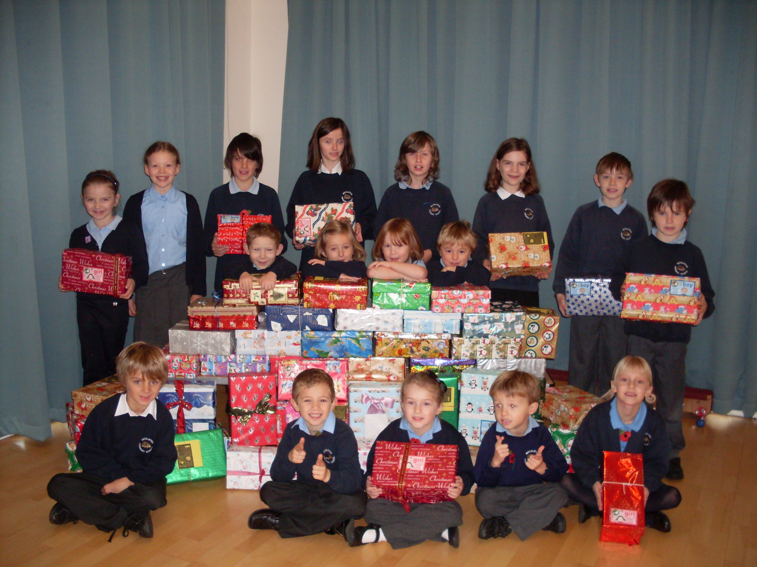
At the beginning of November they sent 56 Christmas presents to children in Belarus via the ‘Operation Christmas Child’ charity appeal. Staff and children alike thoroughly enjoyed collecting small gifts for their boxes and wrapping them. We are sure that the children who receive them will be delighted.

Then on the 11th November the school tag rugby team, ten children from years 5 & 6, played in the Chipping Campden Family Rugby Tournament – and won. Everyone played very well and the whole school was delighted with their success. Pictured is the team with the trophy.
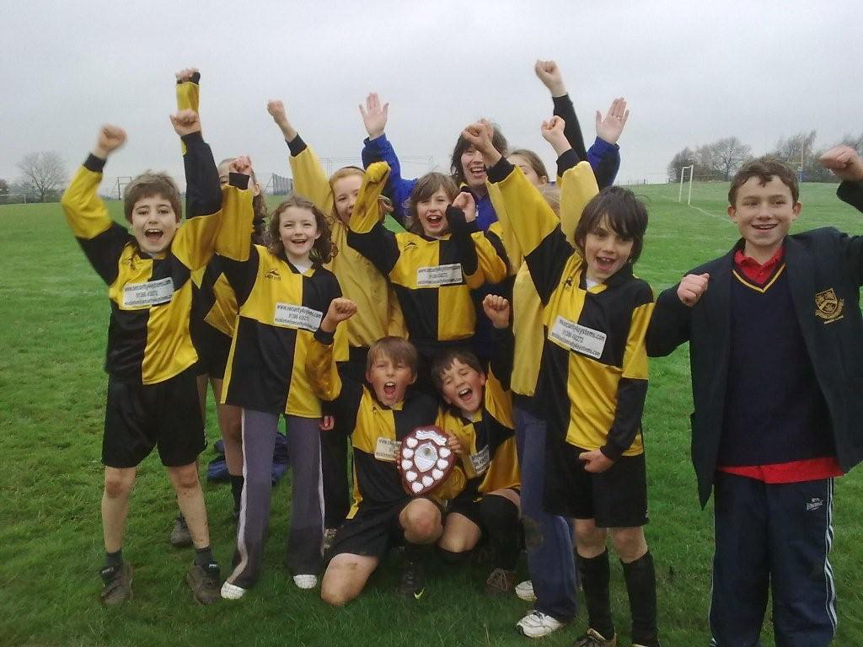

Finally, on 18th November Mickleton School was awarded ‘Healthy Schools Status’ after an extensive validation visit. This is in recognition of our commitment to teaching children about healthy lifestyles. The school council presented a wonderful assembly based on ‘Ready, steady, cook’, making fruit salad and ‘smoothies’ amongst other things. Everyone at Mickleton is delighted by our award; we are now entitled to use the Healthy Schools logo.
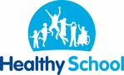

Well done to everyone.

