Foundation Stage Curriculum

- Personal, Social & Emotional Development.

This area of children’s development covers:
  - Having a positive approach to learning & finding out about the world around them.
  - Developing confidence in themselves and their ability to do things as well as valuing their own achievements.
  - Being able to get on with, work with & make friendships with other people, both children & adults.
  - Becoming aware of, & being able to keep to, the rules which we all need to help us to look after ourselves, other people & our environment.
  - Being able to dress and undress themselves and look after their own personal hygiene needs.
  - Developing an understanding that their ways of doing things are respected and to respect other people’s ways of doing things.

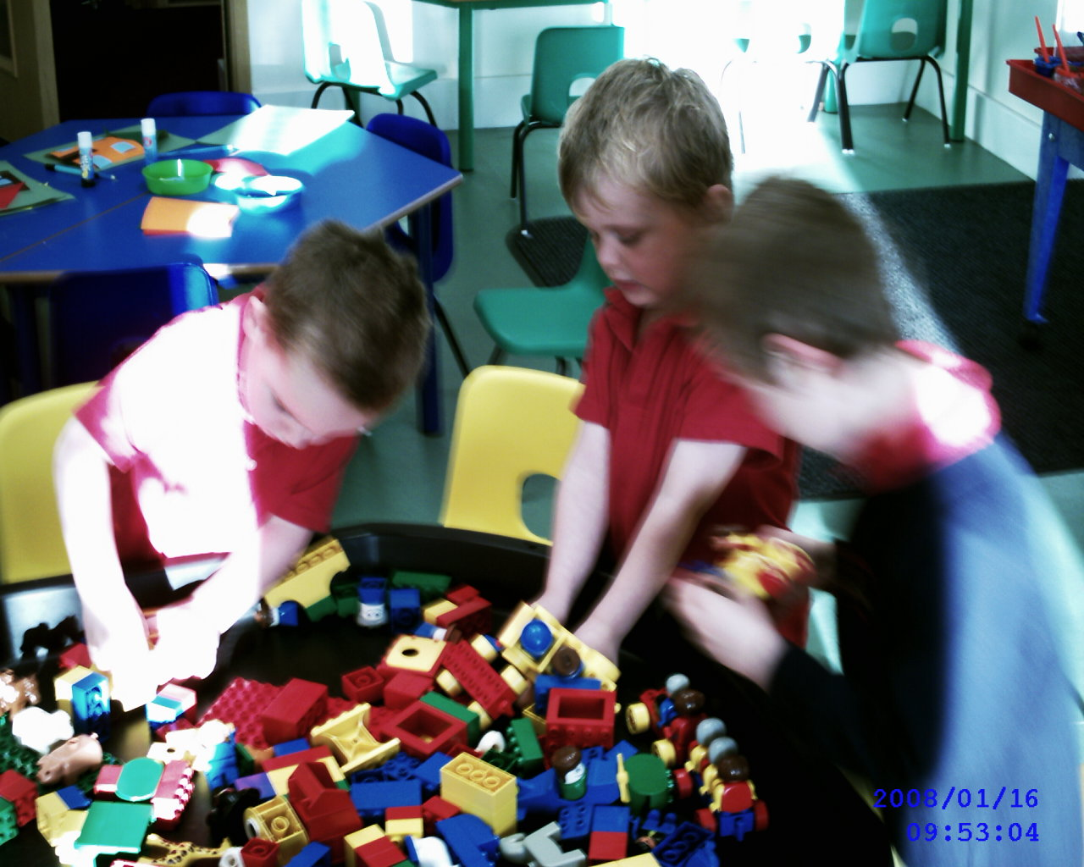
- Communication, Language & Literacy

This area of children’s development covers:
  - Being able to use conversation with one other person, within small and larger groups – talking and listening to others.
  - Adding to their vocabulary by learning the meaning of and correctly using new words.
  - Being able to use words to describe their experiences
  - Getting to know the sounds and letters that make the words we use
  - Listening to & talking about stories
  - Knowing how to handle books and learning that they can be a source for stories & information.
  - Making their own attempts at writing for a variety of purposes (labels, lists, captions, messages etc.)

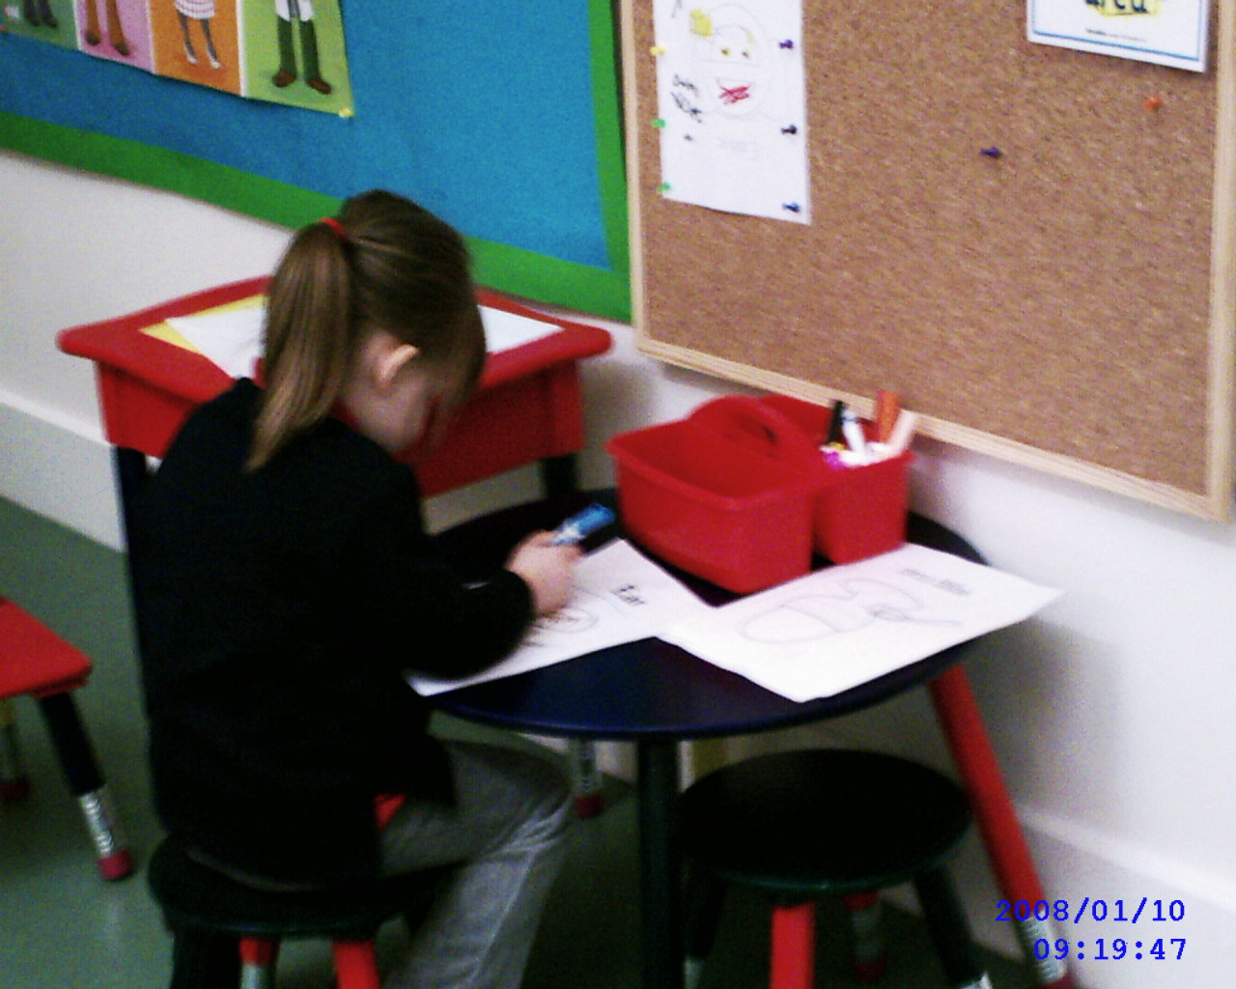

- Problem Solving, Reasoning & Numeracy

This area of children’s development covers:
  - Building up ideas of how many, how much, how far & how big
  - Building up ideas of patterns, shapes & parts of objects and the amount of space taken up by an object (big, biggest etc.)
  - Starting to understand that numbers help us to answer questions about how many, how far & how big.
  - Using counting to answer mathematical questions
  - Being introduced to finding the result of adding or taking away from an amount we already have.

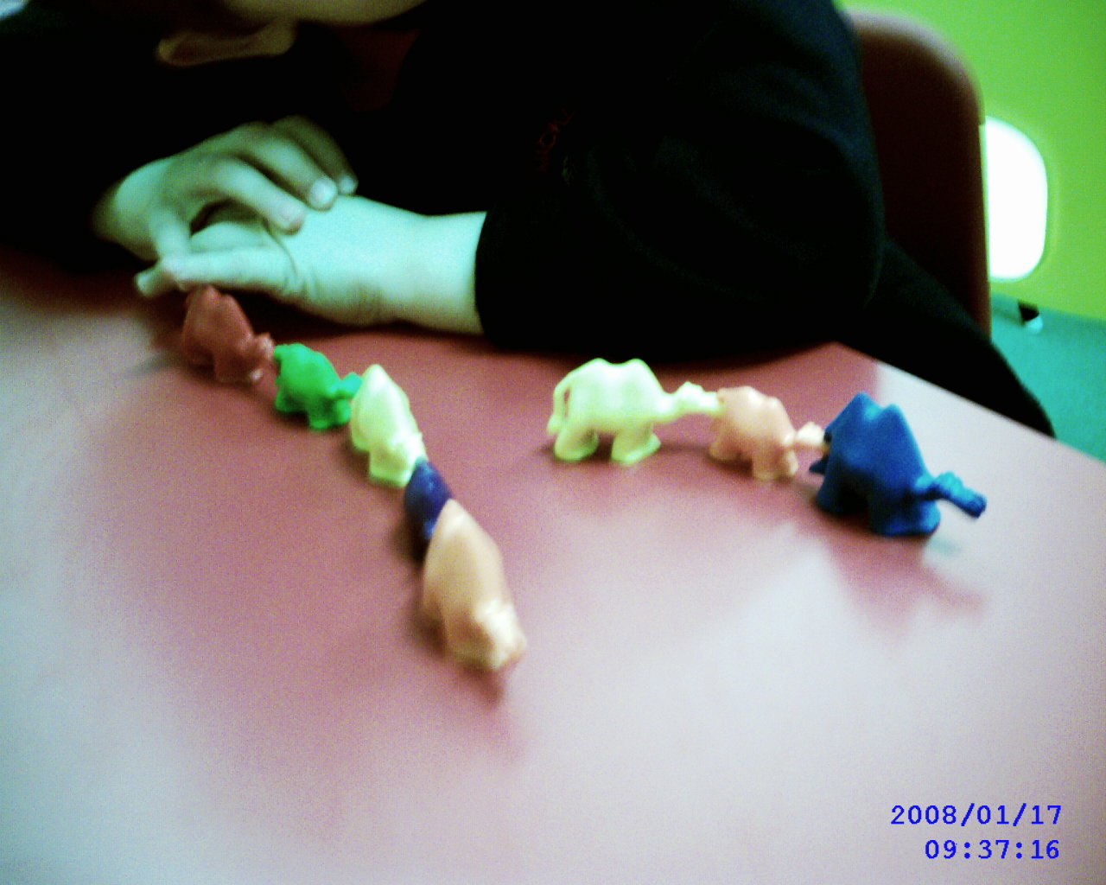

- Knowledge & understanding of the World

This area of children’s development covers:
  - Finding out about the natural and man-made world & how things work
- Learning how to choose and use the right tool for a task.
- Learning about computers, using them and what they can do to help us
- Starting to put together ideas about past and present and the links between them
- Beginning to learn about their locality and its special features.
- Learning about their own culture and those of others.

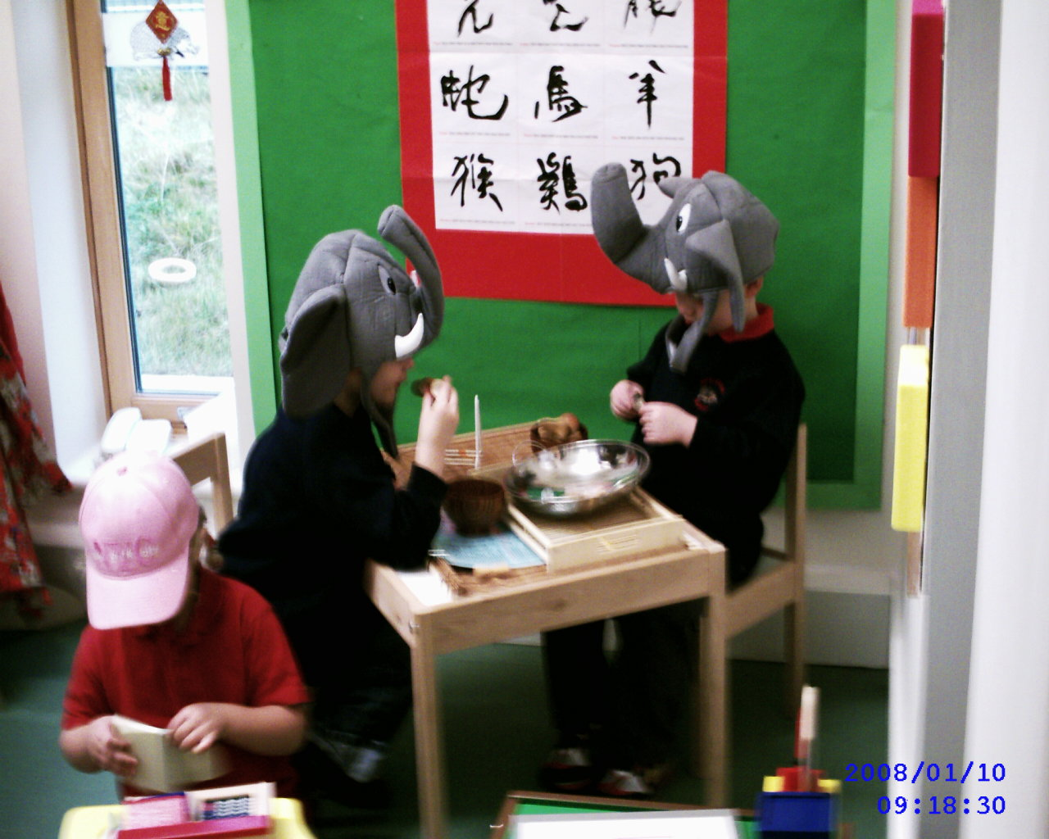

- Physical Development

This area of children’s development covers:
- Gaining control over the large movements that they can make with their arms, legs & bodies – running, jumping, skipping, rolling, climbing, balancing & lifting.
- Developing more control over the small movements they can make with their arms, wrists and hands so they can pick up and use objects, tools and materials.
- Learning about the importance of and how to look after their bodies – keeping healthy

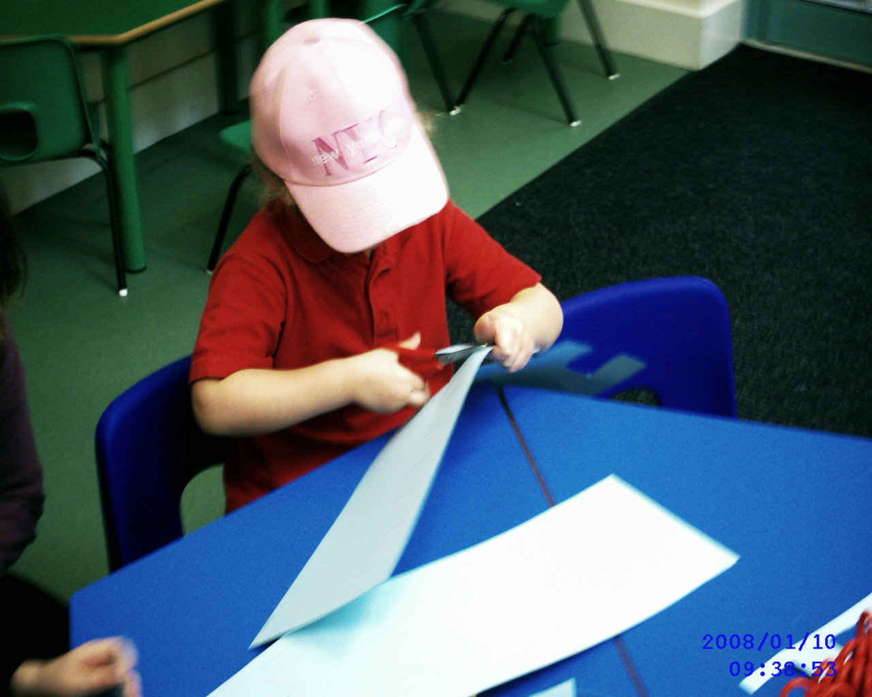

- Creative Development

This area of children’s development covers:
- Using paint, materials, music, dance, words, stories and role-play to express their ideas and feelings & becoming interested in how these differing media can be used in that expression.

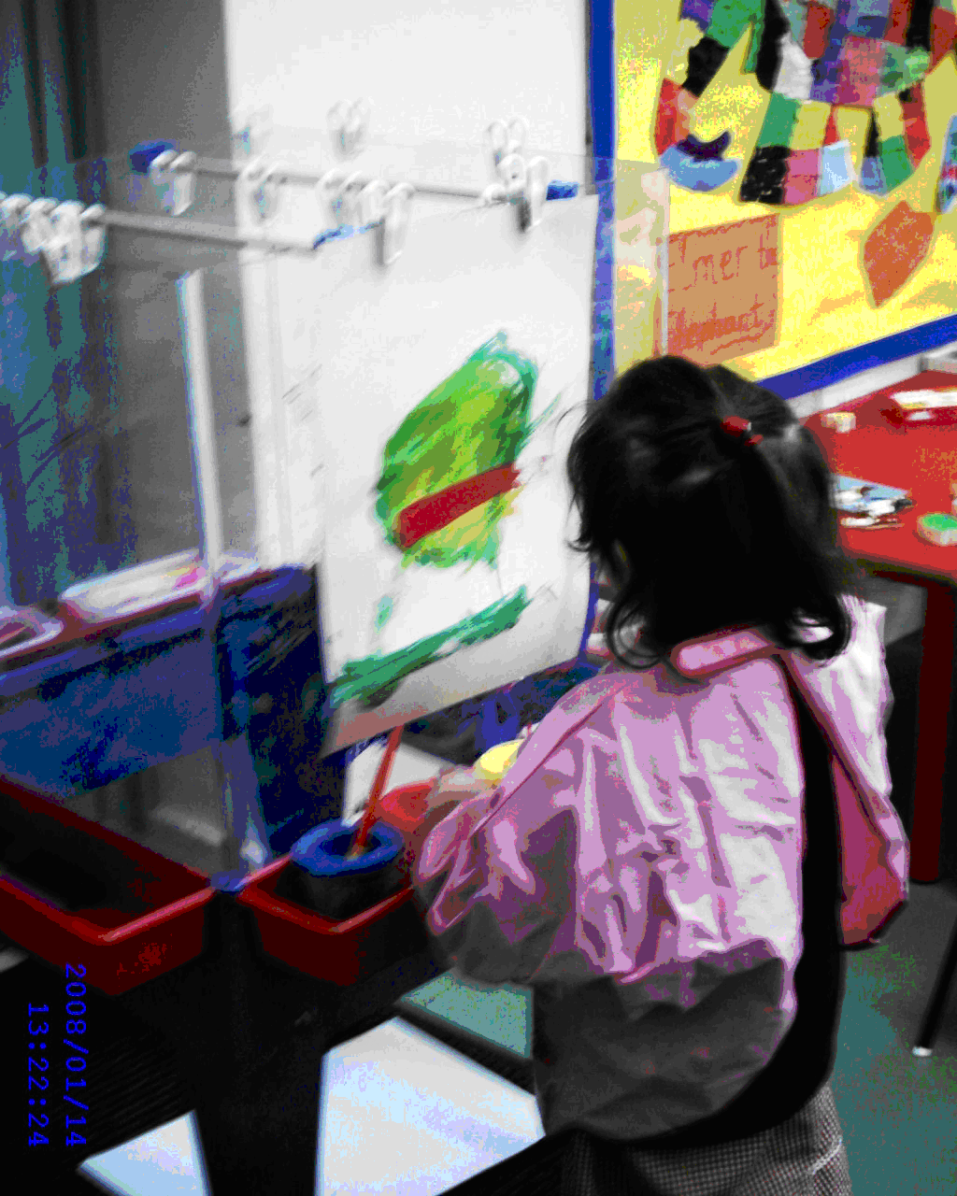

Play helps young children to learn and develop through doing and talking. All six areas of learning are accessed through self-initiated and adult focused play activities.

