Mickleton Primary School

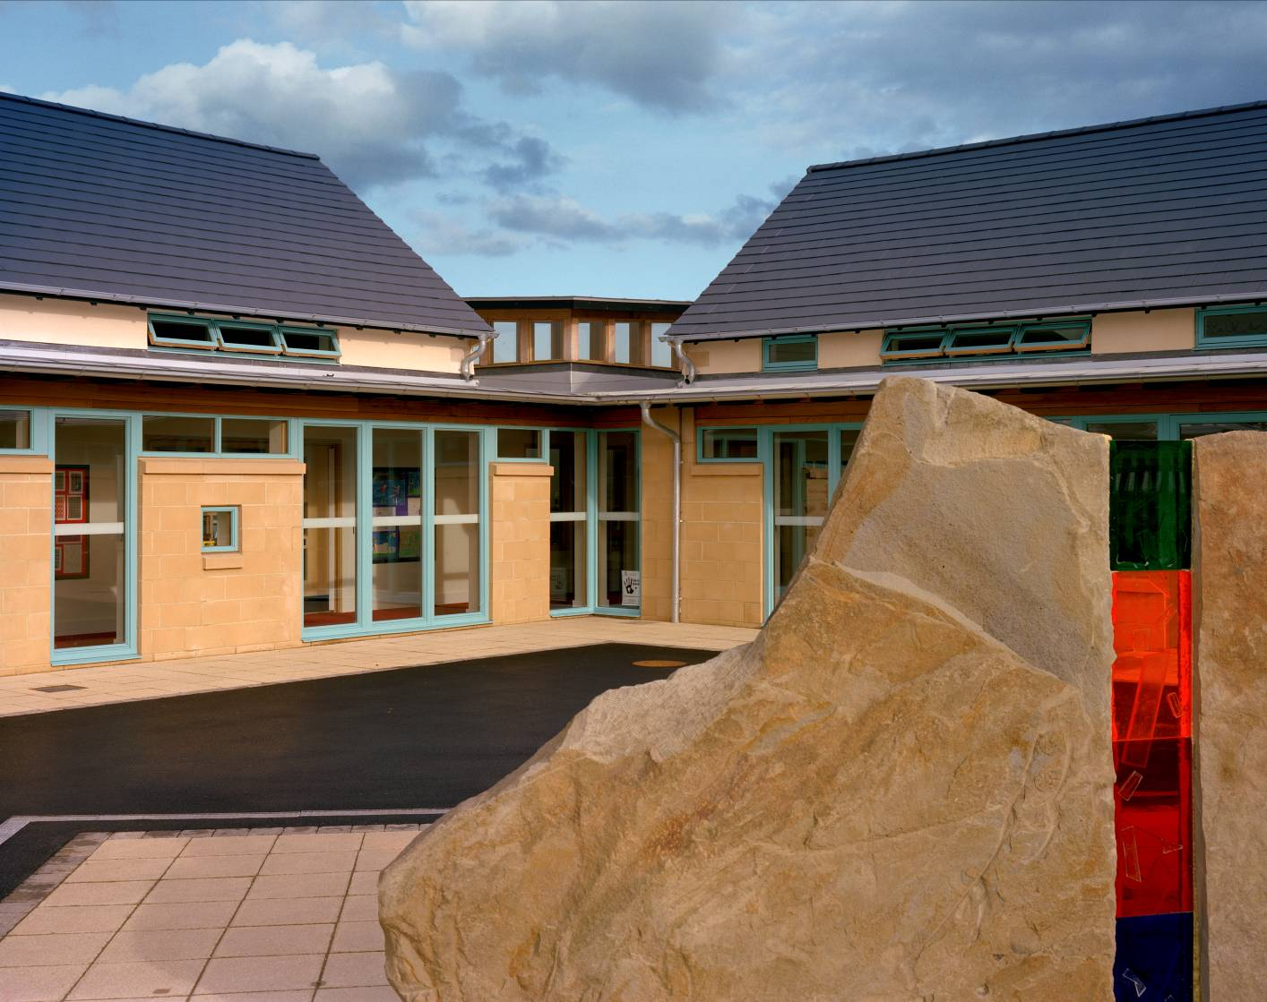

‘Our school is special to us because it is home to friendship, trust and respect.
We value each other; it is the perfect place to learn and play’

GENERAL INFORMATION

Name and address: Mickleton Primary School
Broadmarston Lane
Mickleton
Chipping Campden
Gloucestershire
GL55 6SJ

Telephone no: 01386 438393

Fax no: 01386 438393

Email: admin@mickleton.gloucs.sch.uk

Headteacher: Mrs S A Geary Head Teacher

Chair of Governors: Dr I Hilton

Type of School: Mickleton Primary School is a co-educational day school for pupils between the ages of four and eleven.
It is maintained and financed by the Local Education Authority.

Introduction

On behalf of myself and all staff, I would like to start by saying welcome to Mickleton Primary School!

The aim of this prospectus is to provide parents and carers with information about the many and varied activities that take place at Mickleton Primary School. In this prospectus you will find information pertaining to our school curriculum, the extra curricular activities that are on offer, the school facilities and brief details relating to some school policies, i.e. behaviour and discipline.

At Mickleton Primary School, we pride ourselves on maintaining a happy and welcoming atmosphere for all of our pupils, parents and visitors. Visitors often comment on the ethos of the school and on how industrious and hardworking the pupils are! The Ofsted inspection carried out in November 2006 highlighted the following:

‘ Personal development and well being are good. …… behaviour is good – often exemplary. There is a caring atmosphere and pupils enjoy good relationships with each other and staff.‘

We attempt to provide a balanced and wide ranging curriculum that will allow all the children to achieve success in their work. The more success the children can achieve, the more secure and confident they will become in school. The children will not achieve unless they are happy and enjoying school.

We expect all the children to try their best at all times and our expectations will match these. We all strive for high standards in all academic and non- academic work but we also value the level of respect shown to adults and other children and this is the basis of the high standards of discipline and manners that we expect within the school. By doing this the children will be able to work and play well with each other and at all times we expect the older children to care for and look after the younger children in the school when they need help or are unhappy.

This booklet can only reflect some of the ethos of the school and we encourage you to take the opportunity of visiting the school to experience for yourself a life at Mickleton Primary School.

I hope that you find this prospectus helpful; if however, you have any further questions, please do not hesitate to contact the school.

Where is Mickleton Primary School?

Our school is on the outskirts of the village of Mickleton, which is a thriving and busy community. The school is situated in a beautiful part of the Cotswold countryside, with all of the classrooms looking out onto open fields or rolling hills. Mickleton is approximately two miles from the historic towns of Chipping Campden and eight miles from Stratford Upon Avon.

Background information about the School

Richard Porter of Campden originally endowed a parochial school for Mickleton in 1513.
The school was enlarged in 1889 and again in 1947 when a former carpentry shop was converted for use as a dining hall and a kitchen was built alongside. Temporary buildings were later added to the site and good use was made of the facilities within the village for the delivery of PE lessons.

In 2005, after many years of campaigning and meetings between the school, parish and district councils and the Local Education Authority, it was finally agreed that a new primary school would be built in Mickleton. In September 2006, the pupils of Mickleton Primary School walked through the doors of their brand new school. The new buildings provide a fantastic teaching and learning environment for both pupils and staff and it is a school that we are all immensely proud of.

The school boasts four spacious classrooms, a newly equipped ICT suite, an amazing hall and lots of outdoor space which is used for PE and games lessons as well as an outdoor classroom. The new site also benefits from lots of garden areas and each class has taken on their own areas for growing flowers, vegetables and fruits.
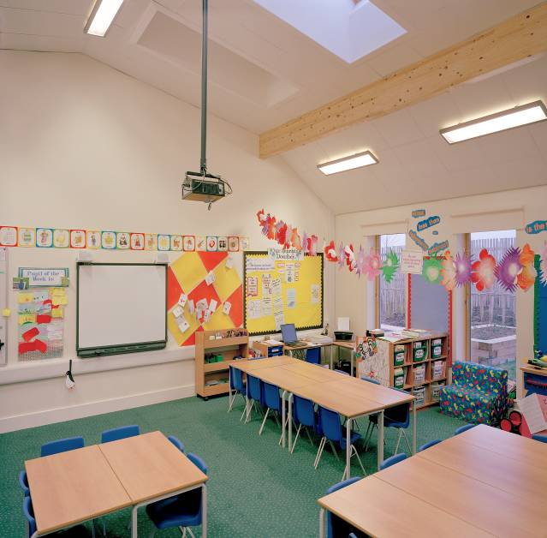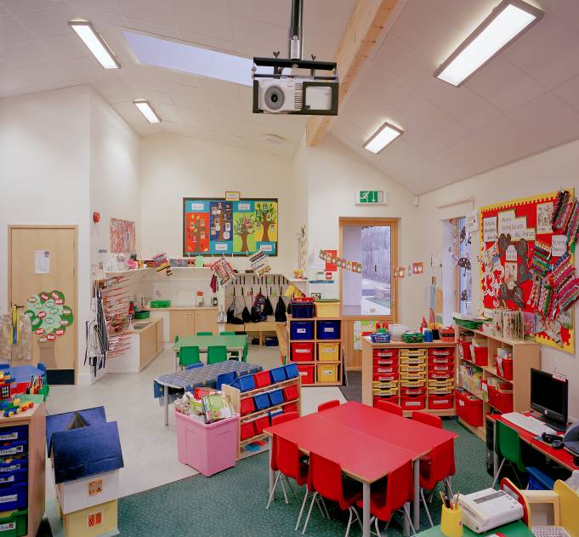

Admission Policy

We currently have approximately 100 pupils on roll who come from Mickleton and surrounding areas of Lower and Upper Quinton, Pebworth and Chipping Campden.

Children are admitted in the Autumn Term of the school year in which they will become 5 years old. The children begin on a part time basis and move quickly into fulltime education. For further information regarding this induction period, please refer to our Foundation Stage prospectus.

Our Standard Admissions number is 15, which means that we are able to take in 15 pupils into our Reception Class each year. This number is set by the Local Education Authority.
All parents who would like to apply for a place at Mickleton Primary School must make their application to Gloucestershire Local Education Authority. The admissions team at the Local Education Authority allocate all places for Reception pupils within the county. They also deal with any appeals submitted by parents. However, parents may in the first instance contact the school and register their child with us.

If a parent requires a place for their child in any other year group, i.e. Years 1 to 6, contact should be made with the school to ascertain if there is a place in the appropriate year group. Admissions to these year groups are dealt with by the school, except in cases of appeal, i.e. if there are no places available and parents decide to appeal against this decision. All appeals for places are dealt with by the admissions team at Gloucestershire Local Education Authority.

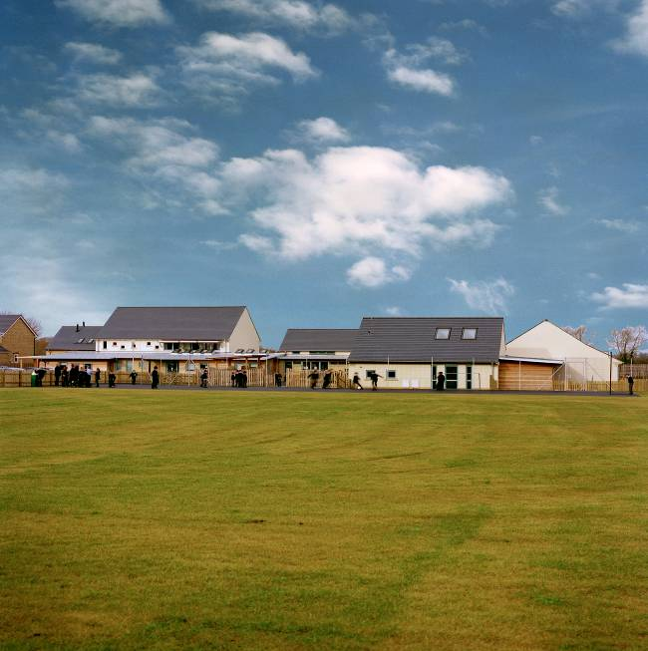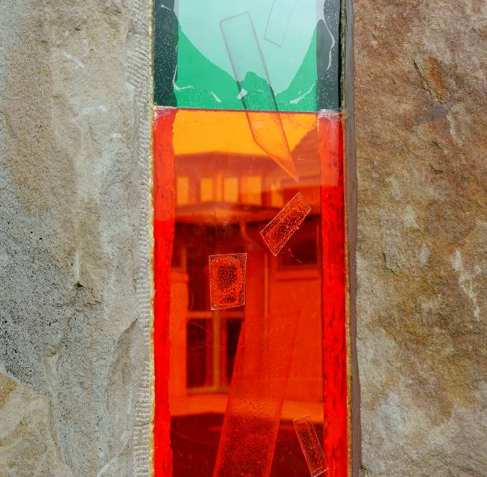

SCHOOL ORGANISATION

The children are taught in three distinct phases within the school:

Foundation Stage: Nursery and Reception
Pupils in this stage are aged from 3-5 years old

Key Stage 1: Years 1 and 2
Pupils in this stage are aged from 5 to 7 years old

Key Stage 2: Years 3, 4, 5 and 6
Pupils in this stage are aged from 7 to 11 years old

In Key Stage 1 and Key Stage 2, the pupils are taught in mixed age classes. The table below outlines the organisation of the classes:

STAGE | NAME OF CLASS | YEAR GROUPS | AGE RANGE
Foundation | Nursery | Foundation 1 | 3-4 years old
Foundation | Class 1 | Reception | 4-5 years old
Key Stage 1 | Class 2 | 1 and 2 | 5-7 years old
Key Stage 2 | Class 3 | 3 and 4 | 7-9 years old
Key Stage 2 | Class 4 | 5 and 6 | 9-11 years old

SCHOOL STAFF

Headteacher: Mrs S A Geary

Reception Teachers: Mrs L Cox / Mrs P Richards

Year 1/2 teacher: Mrs C Thomas

Year 3/4 teacher: Mrs P Hill

Year 5/6 teacher: Mr A Webb

Teaching Assistants: Mrs D Lightfoot (Class 1)
Mrs S Foxhall (Class 2)
Mrs S Caine (Class 3)
Mrs V Gilks (Class 4)

Nursery Early Years’ Mrs D Richardson
Practitioner:

Early Years’ Assistants: Mrs E Flambert, Miss R Caufield

School Administrator: Mrs R Barnett

Caretaker/Cleaner in Charge: Mrs S Walker

Cleaner: Mrs C Parsons

Midday Supervisors: Miss P Bennett
Mrs S Watson
Mrs J Mayrick
Mrs F Fawden

School Governors

Day to day running of the school is in the hands of the staff and the governors have an overall managerial role. The full governors meeting takes place 3 to 4 times during the year and the other individual committees also meet 3 to 4 times a year. Our full list of governors is represented by teacher governors, a representative from the Parish Council, parent governors, LEA elected governors and co-opted governors. We try to involve the governors as much as possible within the school by inviting the subject link governors to observe lessons and meet with the teachers. Governors and staff make up the following committees: Finance and Premises Committee, Curriculum Committee and Personnel Committee.

Personal Development and Behaviour

It is important for children of all ages at Mickleton to be encouraged and rewarded for good behaviour and showing respect towards to others. We all feel that this should be one of our highest priorities as once these attitudes are in place, learning in the classroom becomes much easier and the expected progress will be made.

In our OFSTED inspection (November 2006), it was observed that ‘Pupils feel safe from bullying and free to express their views, which they say are taken seriously by the school.’

To help us achieve this we have put into place several initiatives that will help all of us work towards the best possible learning environment:

- School Behaviour and Discipline Policy

This is a fairly detailed set of guidelines that are given to all members of the school staff. It sets out clear statements regarding: our expectations, rewards, sanctions, bullying, break and lunchtime behaviour, school rules, class rules and parental involvement. You may request to read the policy if you wish;

- Celebration Assembly

Each week the whole school takes part in a celebration of assembly, during which pupils from each class are presented with a ‘Good Effort’ certificate. The certificates can be awarded for a range of different reasons, i.e. for working particularly hard, showing great improvement in a particular subject, being helpful, showing respect to others, demonstrating good behaviour. Certificates and work are displayed for the whole school to enjoy.

- Awarding House Points

House points can be awarded by all members of staff and again for a variety of reasons. The house points are totalled each week and the running total announced in the weekly celebration assembly. The house point cup is awarded to the house with the most number of points at the end of each term.

- Citizenship Award for KS1 and KS2

This is a very special award that is given out at the end of each term and it is given to 1 child in the infants and 1 child in the juniors. All the teachers select children that have always tried their very best throughout the term, demonstrate a very high standard of behaviour and respect towards others in the school and shown an ability to get on very well with the other children in the school. The children are awarded a cup and a book at the end of term assembly;

- School House System

There are four houses in the school: Swifts, Swallows, Hawks and Eagles. Each house has children from reception to Year 6 and children within the same families will be put into the same house.

Children can earn points for their house; house points can be awarded by all members of staff for a variety of reasons. The house points are totalled each week and the running total announced in the weekly celebration assembly. The house point cup is awarded to the house with the most number of points at the end of each term.

Each house also supports a charity that was selected by the children, the charities are:

- Eagles – Vale Wild Life Park
- Swallows – NSPCC
- Swifts – Spring Centre (Handicapped Children) Gloucester
- Hawks – National Canine Defence League (NCDL) Nr. Evesham

The children and teachers organise fund raising events to help raise money for these charities and we encourage the houses to make links with their respective charities.

Assembly

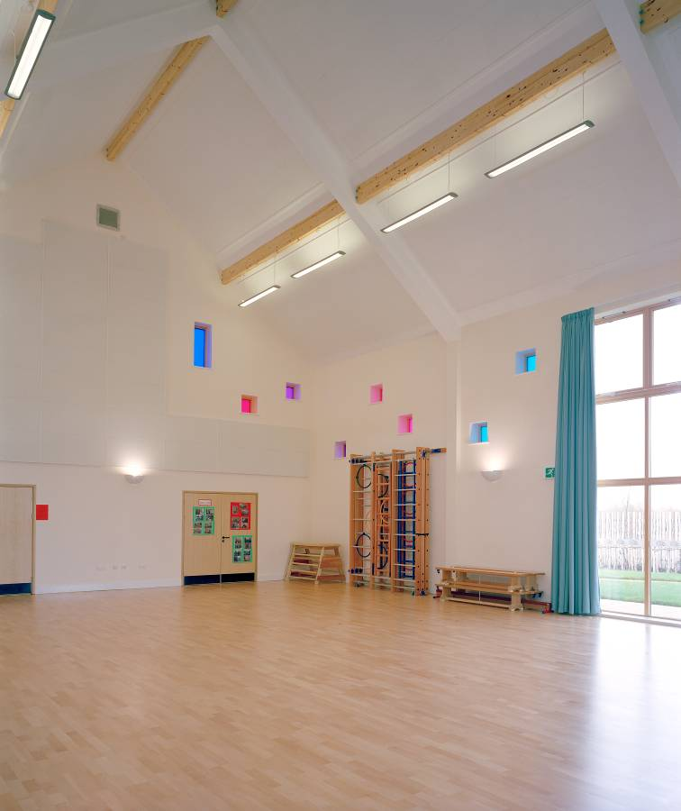
Assemblies form an important part of the school week as they allow the whole school or key stages to come together to learn about social and religious issues. We are extremely fortunate to have good links with the local churches and because of this the vicars from these churches visit us once every week. We also visit St Lawrence Church in Mickleton for Christmas Services and our Leaver’s Service. During the week we have 5 different types of assemblies:

- Hymn practice

- Celebration Assembly: certificates are awarded to children from each class

- Class assemblies

- Whole school assembly

- Visitors’ assembly: (assemblies led by local clergy)
All pupils take part in the above assemblies unless parents inform school that they wish their child to be withdrawn.

The School Curriculum

The school follows the Foundation Stage Curriculum and the National Curriculum.
The Foundation stage curriculum provides the basis of an integrated approach to learning which concentrates on the following six key areas:

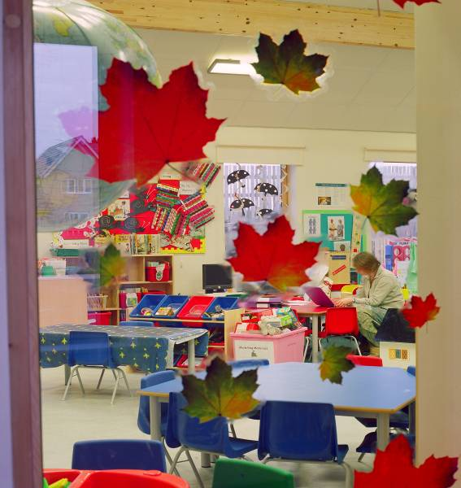

- Personal and Social Development

- Language and Literacy

- Mathematics

- Knowledge and Understanding of the World

- Physical Development

- Creative Development

The National curriculum consists of four core subjects and six foundation subjects as detailed below:

Core Subjects | Foundation Subjects
Numeracy  Literacy  Science  Information, Communication, Technology (ICT) | History  Geography  Art  Music  Physical Education (PE)  Design Technology (DT)

English

The children are taught English through a daily literacy lesson. This is organised in to several parts which include: shared reading/writing, word/sentence level work, guided reading and writing and the plenary section of the lesson.
In shared reading and writing the whole class may study a shared text or writing task. The teacher demonstrates good reading/writing skills and practices and the children contribute to this. This session involves direct teaching of reading and writing skills.
During the word/sentence level work the class will study aspects of phonics, word building, spelling, grammar, punctuation etc.
Guided reading and writing involves the teacher working with a particular group of children of similar ability on either reading or writing. This enables the teacher to give direct instruction on reading/writing and to assist individual children. While the teacher works with the group the other children are involved in group work on tasks relevant to their ability levels. The teaching assistant or another adult may assist these groups.
At the end of the above session the class will come together for the plenary. This part of the lesson allows the teacher to re-emphasise the main points of the lesson and allow the children to discuss the main points.
We do have a library which all the children are allowed to use to enable them to borrow non-fiction books.

Mathematics

Mathematics is taught through a daily numeracy hour. This usually consists of a mental starter, which lasts for 10 minutes, which involves reviewing previous work using mental strategies and encouraging speed of calculation. This is then followed by the direct teaching section of the lesson, which will last for about 30 minutes. During this part the children will work in ability groups on a common theme and the teacher will be involved in direct teaching with a group of children as will the teaching assistant and possibly another adult. The final part of the lesson is the plenary which allows the class to review the main points of the lesson.

Science

In Science, pupils learn about Life processes and Living Things such as plant and animal life cycles, nutrition and growth. They learn about Materials and their Properties; grouping and classifying materials and seeing how they can be changed by heating, cooling, dissolving etc. Pupils are also taught to carry out their own experiments, carefully observing, measuring, fair testing and interpreting their results. Learning about science has a practical basis which makes the most of children’s natural curiosity about the world around them.

Information Communication and Technology (ICT)

Children make use of Information Technology (ICT) in many areas of their work to communicate and handle information. The school’s ICT suite consists of 15 PCs that are networked and linked up to the internet and for email use. The suite is used by all the children in the school from the reception year up to Y6 at least once a week. We are also fortunate to have eight laptops which can be used in the classrooms to support teaching and learning in other areas of the curriculum. These operate wirelessly and are networked to the school’s main server.

Design Technology

Design Technology provides the children with a wonderful opportunity to combine many aspects of the curriculum and use these to help them design, construct and evaluate pieces of work relevant to their study. The children are encouraged to use the relevant tools at the earliest possible age. To emphasis the importance of this subject we organise DT Days which allow the allow the children to work on their designs for 2 days and during this time we withdraw all other curriculum subjects from the timetable.

Geography and History

We are quite fortunate in the village of Mickleton to have a very good resource of features for Geography and History. We use these as a focus as much as we can and this involves visits to local churches, houses and gardens. The children will study these local features and then begin to expand their learning outside the area to other parts of the UK and further a field to locations abroad. The children will be taught various geographical skills such as use of maps, atlas work, coordinates etc. They will also look at weather, climate, population, settlements, natural resources, animals, plants and a great deal of this work is supported by visits and trips to various locations
In Key Stage 1 the children study their own immediate history, thinking about their parents, grandparents and changes, which have occurred in their lifetime. They also learn about stories of famous people and events such as The Great Fire of London and Florence Nightingale. Pupils in Key Stage 2 study a course of history spanning the period from Ancient Egypt to the present.

Music

We are fortunate to have a specialist teacher who comes into school once a week to teach the children Music. The children follow a course of music that involves them in composing, performing and listening to music. They sing and plan pieces of music in groups or as individuals. Recorder lessons are provided to pupils in Year 2 and many other children receive music lessons from our peripatetic teachers who provide lessons in guitar, flute and cornet.

Art

Our programme of study for Art enables the children to experience a variety of media and forms in drawing, painting, sculpture, textiles etc. Children also study examples of work by various artists. We have good links with a local pottery company and we endeavour to ask them to school as much as possible to allow the children to use clay to support the art programme; the children have produced some lovely work as a result of these visits.

Physical Education

We are a fairly small school but we have achieved a great deal of success in many sporting events involving various sports such as football, floorball and shinty. As part of our Physical Education programme we are able to offer the children swimming lessons and these take place at the local secondary school in Chipping Campden. It is done on a rotational system which allows the children from Y2 up to Y6 an opportunity to have an approximate 8 week block of swimming every year.

Religious Education

In Religious Education the children follow a programme of study enabling them to acquire knowledge of religious beliefs and practices and their effects on our lives. They are encouraged to respect and understand the religions of others around the world. A proportion of this work is covered in the class and also during school assemblies.

*based on the Agreed Gloucestershire Syllabus for Religious Education

Questions about the syllabus and the option of withdrawal may be discussed with the Head teacher.

Personal and Social Health Education (PSHE)

Personal and Social Health Education involves the teaching of personal health and safety matters and issues arising from the social environment in which our children live. The aims of PSHE are to equip the children with the necessary knowledge to care for themselves, particularly keeping themselves safe and looking after their bodies. It should also help them develop the appropriate social skills to cope with other children and adults and behave in the correct manner.

Aspects of Sex Education are covered with the children in Y6. Parents are informed about what we will cover with the children and part of this programme involves a video and talk provided by the school nurse. Parents may opt to withdraw their children from this talk if they wish to do so. If they require information they are very welcome to talk to the Y6 class teacher.

Special Educational Needs

Children with Special Educational Needs are very welcome at our school. Learning needs, physical and behavioural needs are all taken seriously. We will assess any children we feel that may need to be put onto our SEN register and the parents will be informed of the results and the future strategies that may be put into place to aid progress. Extra support is given to children with specific needs as extra teaching has been allocated for our teaching assistants and the headteacher.

We are aware that we do have some children who are more able than the rest of the children in the class. During the year we will identify these children and the headteacher will work with them on specific curriculum areas that will extend their class work. Initially this will be with children in the Key Stage 2 classes.

Assessment

All children are assessed on an on going basis. Teachers constantly monitor children’s progress in lessons and adjust their planning accordingly. Staff also monitor pupil progress in all subjects through specific activities and observations.

Pupils in the Reception Class are assessed against the Foundation Stage Profile, which is directly linked to the early learning goals in the Foundation Stage Curriculum.

Children are more formally assessed at the ages of seven and eleven (end of Year 2 and Year 6) when they undertake the national tests ‘SATs’.* These tests assess the children’s progress against the levels of attainment in the National curriculum. Teachers in Year 2 are required to administer the tests to support their teacher assessment of each pupil. Children in Year 6 sit tests in English, Mathematics and Science.

Pupils in years 3, 4 and 5 also take ‘optional SATs’ which provide the school with evidence of progress in Mathematics and English.

*SATs: Standard Assessment Tasks and Tests

Homework

We believe that homework can play a very important part in the children’s learning as it allows them to review their school work in a very different environment and encourages levels of independence away from the classroom. The children will never be given work that is new to them or involves concepts they have not covered in class. We have a fairly detailed Homework Policy and also Guidelines for Parents that you will need a copy of. At the start of each academic year the school provides the parents with a timetable of homework tasks for each year group and the days the work should be returned.

We appreciate the support of parents in monitoring homework and ensuring that the children can work in quiet and relaxed conditions with as little to distract them as possible.

Throughout the school, emphasis is put on reading, spelling and mathematics but from time to time the children will be asked to bring in items to support science or project work.
All the children have Homework Diaries which we ask that you check and sign. The diaries will inform you of the homework that needs to be completed; it may also include additional notes from the class teacher. The homework diaries should be taken to school everyday.

All the children up to Y5 and Y6 will have a home reading diary, which they will use to record the reading books they take home; this book should also be used by parents to make comments on their child’s reading.

The approximate time allocated to homework is set below, if you feel that your child is far exceeding this then please contact the teacher as soon as possible:

Reception: 10 – 15 minutes per night (reading, handwriting and phonics)

Y1 and Y2: 15 – 20 minutes per night (reading, spelling, phonics and maths)

Y3/4: 20 – 25 minutes per night (reading spelling and maths)

Y5/6: 30 – 40 minutes per night (reading, spelling, maths, science/topic)

We expect all the children to complete their homework and hand it back to the class teacher on the correct day. If the homework is not brought into school we ask the children to stay in during lunchtime to complete the work and this will include children who have completed the work but forgot to bring it in. If the child produces a letter from their parents explaining why they have not handed the work in, they will be excused from the ‘Homework Club’ and be expected to hand it in the following day.

Equal opportunities and Race Equality

The school has both an equal opportunities and race equality policy. These policies outline our commitment to provide for all members of the school community regardless of gender, race, culture or background. The school seeks to promote equality and racial harmony. Pupils of all ages take part in PSHE lessons which provide them with opportunities to discuss a range of issues, i.e. relating to stereo typing and racism.

Reporting to Parents

Parents’ Evenings are held in November and March. These provide parents with the opportunity to discuss their child’s progress with the class teacher.
Written reports are prepared for each child at the end of the school year. These provide a detailed account of your child’s levels of attainment and achievements.

We urge the parents to contact the school at any time during the year if they have any concerns about their child’s education or welfare, no matter how trivial. It is absolutely crucial that any concerns that you may have are addressed immediately and not left unresolved or at worst approached during the final parent’s evening. The headteacher or teachers can see you briefly before or after school but please arrange an appointment if you wish to raise a matter requiring greater privacy or a longer discussion period. If we are concerned about your child’s progress or behaviour then we will contact you immediately.

We endeavour to pass as much information as we can to parents and this is done using various forms of communication:

- Regular newsletters;

- Curriculum newsletters at the start of the terms;

- Information evenings for parents on a range of subjects;

- Open Days.

Complaints Procedure

We hope that if a parent has a complaint to make, that it can be resolved quickly and satisfactorily. If parents wish to make a complaint, they should follow the complaints procedures as outlined on the attached sheet.

School Uniform

The school uniform, agreed between the school, governors and the Friends of the School is as follows:

Girls

Summer Blue checked dress, school cardigan or school sweatshirt. (girls may wish to continue wearing the winter uniform)

Winter Pinafore dress, skirt or trousers (grey or navy blue)
Blouse (blue) or school polo shirt
School sweatshirt, school cardigan or jumper

Boys

Summer and Winter

Trousers or shorts (grey)
Shirt ( pale blue) or school polo shirt
School sweatshirt / jumper (navy blue)

We strongly encourage all the children to wear the correct school uniform so they look smart and give Mickleton School a positive identity in the community. We hope it will help the children develop family loyalty to the school.

Jewellery: children are permitted to wear watches and stud ear-rings. For health and safety reasons, no other jewellery should be worn.

Games and PE Clothing

Boys and Girls

School PE T shirt
Shorts (navy blue)
Pumps/trainers

In winter a tracksuit or sweatshirt and tracksuit bottoms may be worn (navy blue or black)

It is essential, for reasons of health, comfort and safety that a change of clothing is provided for these lessons. The PE should be placed in a named ‘kit’ bag. If the correct kit is not worn or left at home, the child will not take part in the PE lesson and the parents will be informed. We will not call home for the kit to be brought in.

Please ensure that all articles of clothing and other belongings are clearly labelled with your son/daughters name.

For reasons of safety, the children are not allowed to wear jewellery (including watches) for PE lessons. If your child has pierced ears and is unable to take their ear-rings out, please ensure that they have tape to cover their ear-rings.

Extra Curricular Activities

We provide a number of clubs and extra curricular activities after school and several of these are linked up to the school sports teams. We currently offer the following clubs:

- Football (Key Stage 2)
- Netball (Key Stage 2)
- Cross Country (Key Stage 2)
- Art (Key Stage 1& Key Stage 2)
- Sewing (Key Stage 2)
- Athletics/Ball Skills (KS2 during Summer Term)
- Choir
- Floor ball (Key Stage 2)

Letters are sent home regarding the clubs and sometimes we do need to put an upper limit on the numbers so we organise these on a first come first served basis.

Absences and Holidays

Following visits from the Area Welfare Officer we have been advised of the necessity for written notification of absence on your child’s return to school even if we have received a message by telephone. Please could you inform the School Office of your child’s illness before 10.00am on the first day of absence. If you do not call then we are required to call you.

If your child has a dental/doctor’s appointment, please provide a note to arrange the early collection of your child. Holiday request forms are available at the office.

‘Authorised’ and ‘unauthorised’ absences are explained below:

Authorised

- Any length of absence due to illness when a note is provided from the parents within 1 week of the child’s return;
- Doctor, dentist, hospital appointments when a note is provided;
- 10 days of holiday leave when the correct school holiday form is signed by the headteacher;
- Examinations: for example, 11 Plus, dance, drama, music exams.

Unauthorised

- Any length of absence due to illness and a note is not provided within 1 week of the child’s return;
- Holiday leave that extends beyond the 10 day permitted limit;
- Care for siblings;
- Days off to visit relatives, birthdays etc.

Medical Care and Medicines

From time to time the nurse, doctor, dentist and audiologist may visit the school to carry out routine health inspections, dental inspections, vision and hearing tests. Parents will be advised if further examinations are required.

Should your child become ill or have an accident requiring more than first aid, we will contact you. It is important therefore that you provide telephone contacts on your registration forms. Please let us know if your child has any allergies or health problems.

Staff who administer medicine to children do so voluntarily. If parents require a member of staff to administer medicine to their child, it is essential that a signed letter is sent into school requesting this. Parents must given written permission for the medicine to be administered and the exact dosages and times must be detailed in the letter. Medicine spoons must also be provided. If this information is not given in writing, staff will not be able to administer the medicine and parents will be contacted to come into school to administer it themselves.

School Meals

School Meals are eaten in the school hall and children can choose to have a cooked meal or a packed lunch. The school has its own kitchen in which cooked meals are prepared on a daily basis. The meals are cooked by Sodexo Catering Service and there is always a choice of a main meal and dessert that the children can select from.

School meals can be paid for at the beginning of the week and it is not necessary for the children to have the cooked dinners on each day of the week as they may prefer to only have them on 2 or 3 days of the week.

When children start school in reception, we give parents a ‘healthy packed lunch leaflet’ given to us by the school nurse. We encourage all children to bring a healthy packed lunch and ask that they do not bring fizzy drinks. Drinks should be provided in cartons or plastic bottles/cups and not glass containers. We also ask that parents do not provide their children with hot drinks or soups as these can easily be spilt.
Please ensure that all lunch boxes and drinks containers are named as many children often have the same ones!

Parental Involvement and Friends of the School

We welcome and enlist the support of parents in all the classes within the school. Parents help us with many classroom activities throughout the school and this may involve listening to children read, working with small groups, changing home readers, helping in the library or attending class visits. If you would like to help in the school, please contact the class teacher.

The Friends of the School was formed in 1988 and has become extremely valuable to the school, not only in raising funds to improve educational resources but also in fostering good relationships between the home, school and community.

Who can join Friends of the School?

- Parents and guardians of pupils;
- Other relatives of pupils;
- Members of staff;
- Governors;
- Past pupils and retired members of staff;
- Members of the local community.

Aims of the Association

- To advance the education of the pupils by providing educational facilities at the school (not normally provided by the Local Educational Authority)
- To foster good relationships between the parents, staff, governors and local community;
- To engage fund raising and social activities which support these aims.

If you would like more information or think you would like to join FOS please contact the school and we will be happy to put you in touch with the chairperson.

Charging and Remissions Policy

The school wishes to provide for all pupils the best possible educational opportunities available within the funds allocated by the Education Authority.

The school’s concern is to keep the financial contributions to a reasonable minimum and to ensure as far as possible that all the children are able to take part in visits, irrespective of their circumstances.

Parents may be asked for voluntary contributions towards certain aspects of day and residential visits and without this financial support the school would find it impossible to maintain the quality and breadth of the educational programme provided for the pupils.

Charges may be waived or reduced in certain circumstances.

Charges are made for specialist music lessons.

Educational Visits

We arrange a number of visits during the year in connection with the work we are doing in the classroom. Y3/4 and Y5/6 pupils have the opportunity to go on a residential visits. We feel that the social and educational value of these visits is very important and we are anxious that no child should ever be excluded for financial reasons.

Please contact the headteacher in confidence in any such case.

Transfer to Secondary School

Children normally transfer to Chipping Campden Secondary School after Year 6. Details of the transfer will be given to the parents of Year 6 children. Please contact the secondary school for information on their Admissions Policy (this is important if you live out of county)

